**AI BASED DIABETES PREDICTION USING AI TECHNOLOGIES**

**PHASE -5**

**NAME : Lavanya.s**

**NM id : au513521106016**

**Gmail id : balajinandhinib86@gmail.com**

**INTRODUCTION:**

Artificial Intelligence (AI) has revolutionized healthcare by offering innovative solutions to predict and manage various medical conditions, and one area where AI has made a significant impact is diabetes prediction. Diabetes is a chronic and widespread metabolic disorder that affects millions of people worldwide. AI-based diabetes prediction leverages advanced algorithms, machine learning techniques, and big data analysis to assist in the early detection and management of diabetes. By analyzing a range of patient data, including medical history, genetic information, lifestyle factors, and biomarkers, AI can generate accurate predictions about an individual's risk of developing diabetes.

These predictive models not only help in identifying high-risk individuals but also offer personalized recommendations for lifestyle modifications and preventive measures, ultimately reducing the burden of diabetes-related complications and healthcare costs. AI-based diabetes prediction systems are a prime example of how technology can empower healthcare professionals and individuals to proactively address a global health challenge, fostering a more proactive and personalized approach to diabetes management.

**GIVEN DATASET LINK:**[**https://www.kaggle.com/datasets/mathchi/diabetes-data-set**](https://www.kaggle.com/datasets/mathchi/diabetes-data-set)

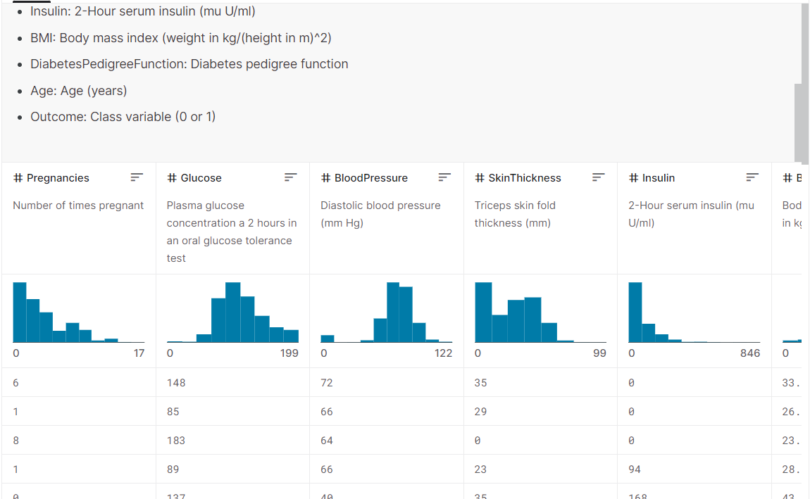

**HERE THE LIST OF TOOLS THAT ARE COMMONLY USED IN THE PROGRESS:**

The process of AI-based diabetes prediction involves several steps, and there are various tools commonly used at each stage to facilitate the analysis and prediction. Here is a step-by-step list of these tools:

1. **Data Collection and Preprocessing:**

- **Python:** Python is a popular programming language for data analysis and machine learning.

- **Pandas:** A Python library for data manipulation and analysis.

- **NumPy:** Used for numerical operations on data arrays.

- **SciKit-Learn:** Provides tools for machine learning, including preprocessing functions.

- **SQL or NoSQL Databases:** For storing and managing large datasets.

2. **Feature Engineering:**

- **Jupyter Notebook:** An interactive environment for data exploration and feature engineering.

- **Feature selection libraries:** Like scikit-learn's `SelectKBest` or `SelectFromModel` for selecting relevant features.

3. **Model Development:**

- **Scikit-Learn:** Offers various machine learning algorithms for classification, regression, and model evaluation.

- **TensorFlow and PyTorch:** For building deep learning models.

- **AutoML Tools:** Such as Google AutoML or H2O.ai, which automate the model selection and tuning process.

4. **Model Evaluation:**

- **Scikit-Learn:** For metrics like accuracy, precision, recall, F1-score, and ROC curves.

- **Confusion Matrix Visualization Tools:** Like Seaborn and Matplotlib.

- **Cross-Validation Libraries:** For estimating model performance more robustly.

5. **Deployment and Integration:**

- **Flask or Django:** Python web frameworks for building a web-based interface for the model.

- **Docker:** For containerization of the AI model.

- **Cloud Services:** Such as AWS, Azure, or Google Cloud for scalable deployment.

6. **Data Monitoring and Maintenance:**

- **Monitoring Tools:** To keep an eye on model performance and data quality.

- **Scheduled Jobs:** For periodic model updates and retraining.

- **Database Management Systems:** To store and manage prediction results and user data.

7. **User Interface (Optional):**

- **HTML/CSS/JavaScript:** For creating user-friendly web interfaces.

- **React, Angular, or Vue.js:** Frameworks for building interactive front-end applications.

8. **Privacy and Security (Critical for healthcare applications):**

- **HIPAA-Compliant Tools and Practices:** Ensuring compliance with healthcare data security regulations.

- **Data Encryption Tools:** To secure data at rest and in transit.

- **Access Control and Authentication Systems:** To control who can access patient data.

Remember that the choice of tools may vary based on the specific requirements and constraints of the project. Additionally, it's important to ensure that the handling of medical data is in compliance with relevant healthcare regulations and standards to protect patient privacy and data security.

**1.DESIGN THINKING AND PRESENT IN FORM OF DOCUMENT**

Design thinking is a user-centered, iterative approach to problem-solving and innovation. To present a design thinking document for an AI-based diabetes prediction system, you can use a structured format that includes the key stages of design thinking: empathize, define, ideate, prototype, and test. Here's an example document outlining these stages:

1. Empathize

**Goal:** Understand the needs and concerns of individuals at risk of diabetes, healthcare providers, and stakeholders.

**Activities:**

- Conduct user interviews and surveys to gather insights.

- Analyze existing healthcare data and statistics.

- Engage with healthcare professionals for expert opinions.

**Key Insights:**

- Many individuals lack awareness of their diabetes risk.

- Healthcare providers need accurate and accessible predictive tools.

- Data privacy and security are significant concerns.

2. Define

**Goal:** Clearly define the problem and establish the project's scope.

**Activities:**

- Create personas for end-users.

- Define the project's goals, objectives, and constraints.

- Develop a problem statement.

**Problem Statement:**

"Individuals at risk of diabetes lack a user-friendly and accurate tool for early prediction and personalized risk management, and healthcare providers need an efficient system to assist in diabetes prevention."

3. Ideate

**Goal:** Generate creative solutions to the defined problem.

**Activities:**

- Conduct brainstorming sessions with the project team.

- Seek inspiration from AI and healthcare experts.

- Encourage "out-of-the-box" thinking.

**Ideas:**

- Develop a mobile app for users to assess their diabetes risk.

- Utilize AI to create personalized diabetes risk profiles.

- Implement a web-based platform for healthcare providers to access patient data.

4. Prototype

**Goal:** Create tangible representations of the proposed solutions.

**Activities:**

- Develop wireframes for the mobile app.

- Design mockups of the AI prediction interface.

- Create a prototype of the web-based platform.

5. Test

**Goal:** Gather feedback and refine the prototypes.

**Activities:**

- Conduct usability tests with potential users.

- Collect feedback from healthcare professionals.

- Analyze the usability and accuracy of the AI prediction model.

**Feedback:**

- Users find the mobile app easy to use but want more educational content.

- Healthcare providers value the platform's data visualization but suggest real-time data integration.

6. Refine and Iterate

**Goal:** Use the feedback to make necessary improvements to the prototypes.

**Activities:**

- Refine the mobile app with additional educational content.

- Enhance the web-based platform for real-time data integration.

- Fine-tune the AI prediction model for increased accuracy.

7. Final Solution

**Goal:** Present the final AI-based diabetes prediction solution.

**Components:**

- Mobile app for users to assess diabetes risk.

- AI model for personalized risk prediction.

- Web-based platform for healthcare providers.

## 8. Implementation Plan

**Goal:** Outline the plan for implementing the solution.

**Activities:**

- Development of the mobile app, AI model, and web platform.

- Data integration and privacy measures.

- User training and onboarding.

## 9. Evaluation and Continuous Improvement

**Goal:** Establish a system for ongoing evaluation and improvement.

**Activities:**

- Regularly gather user feedback.

- Monitor the performance and accuracy of the AI model.

- Address data privacy and security concerns.

By following this design thinking process, we have created a user-centric AI-based diabetes prediction system that not only addresses the needs of individuals and healthcare providers but also prioritizes data privacy and security. This approach ensures that the solution is effective, user-friendly, and adaptable for future improvements.

**2:DESIGN AND INNOVATION:**

Step-by-step guide to designing an innovation for AI-based diabetes prediction:

1. Identify a problem to solve. What are the limitations of current AI-based diabetes prediction systems? What are the unmet needs of patients and caregivers?
2. Brainstorm possible solutions. How can AI be used to improve diabetes prediction in new and innovative ways? Consider different approaches, such as using new data sources, developing new machine learning algorithms, or integrating AI with other technologies.
3. Evaluate potential solutions. Assess the feasibility, cost-effectiveness, and potential impact of each solution.
4. Develop a prototype. Create a working prototype of your solution to test its feasibility and gather feedback from users.
5. Test and refine the prototype. Conduct user testing and gather feedback to iterate on and improve your prototype.
6. Deploy the solution. Once the prototype is refined and tested, deploy it to a wider audience.

Here are some specific examples of innovations that could be developed for AI-based diabetes prediction:

* Develop a more accurate and personalized risk assessment tool. Current AI-based diabetes prediction models are still relatively inaccurate, and they do not take into account all of the individual risk factors for diabetes. Developing a more accurate and personalized risk assessment tool would help to identify individuals at high risk of developing diabetes earlier, so that they can take preventive measures.
* Develop a system that can predict the onset of diabetes complications. Current AI-based diabetes prediction models can only predict the risk of developing diabetes itself. Developing a system that can predict the onset of diabetes complications would help patients and caregivers to better manage their disease and reduce their risk of serious complications.
* Develop a system that can integrate AI-based diabetes prediction with other technologies, such as wearable devices or electronic health records. This would allow for more continuous and personalized monitoring of a patient's risk of diabetes and diabetes complications.

Overall, the goal of designing an innovation for AI-based diabetes prediction is to improve the accuracy, personalization, and accessibility of diabetes prediction. This can be done by developing new machine learning algorithms, using new data sources, and integrating AI with other technologies.

Here are some additional considerations for designing an AI-based diabetes prediction system:

* Data privacy and security: AI-based diabetes prediction systems collect and process sensitive patient data. It is important to ensure that this data is protected from unauthorized access and use.
* Transparency and accountability: AI-based diabetes prediction systems should be transparent about how they work and how they make decisions. This is important for building trust with patients and caregivers.
* Equity and inclusion: AI-based diabetes prediction systems should be designed and evaluated in a way that ensures that they are fair and equitable for all patients, regardless of race, ethnicity, socioeconomic status, or other factors.

By carefully considering these factors, it is possible to design AI-based diabetes prediction systems that are safe, effective, and beneficial for patients and caregivers.

**DIABETES PREDICTION USING DECISION TREE TECHNIQUE:**

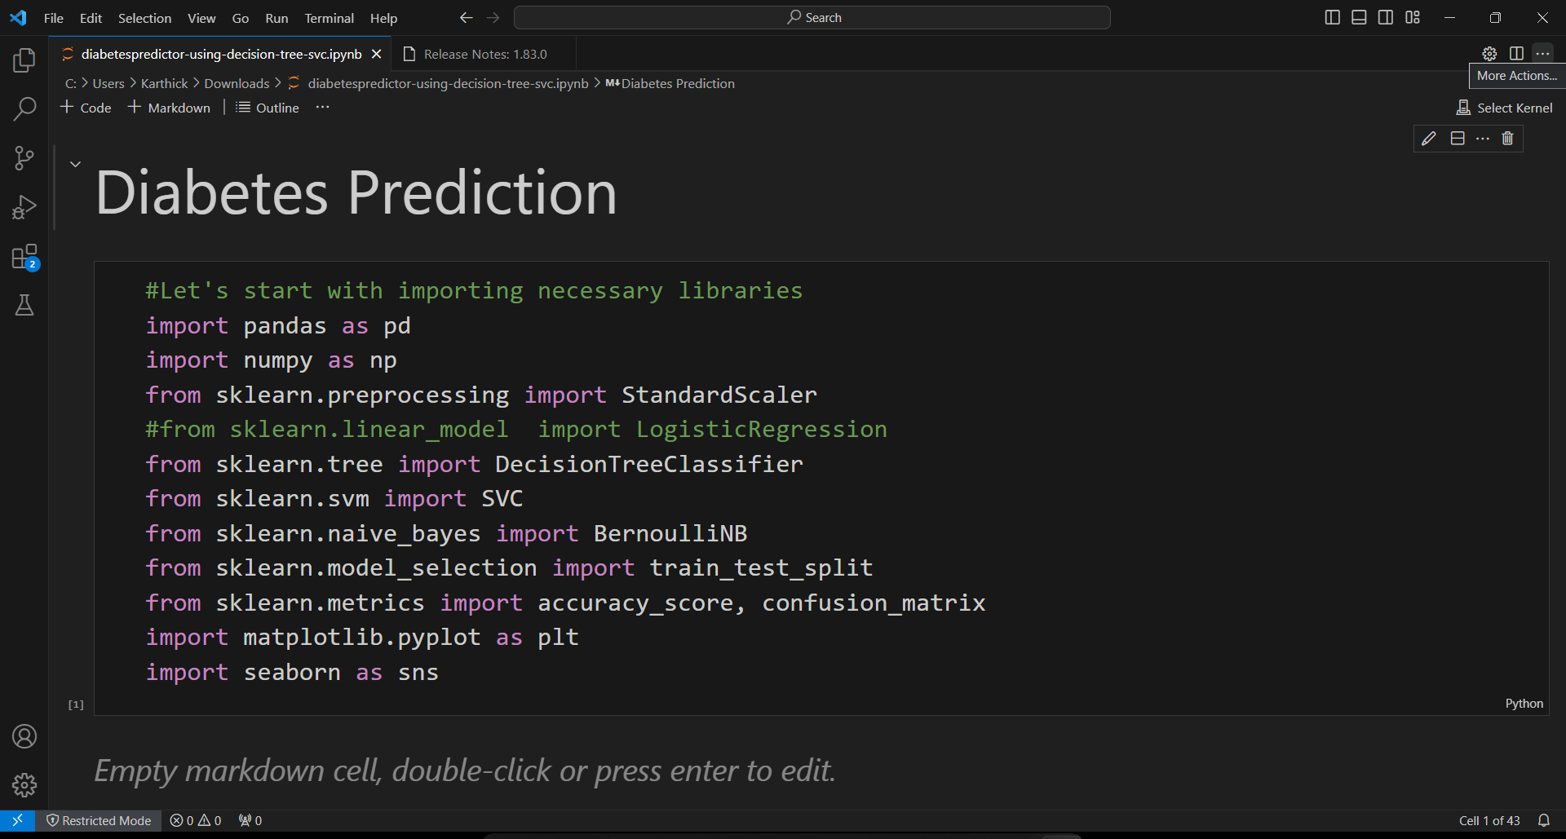

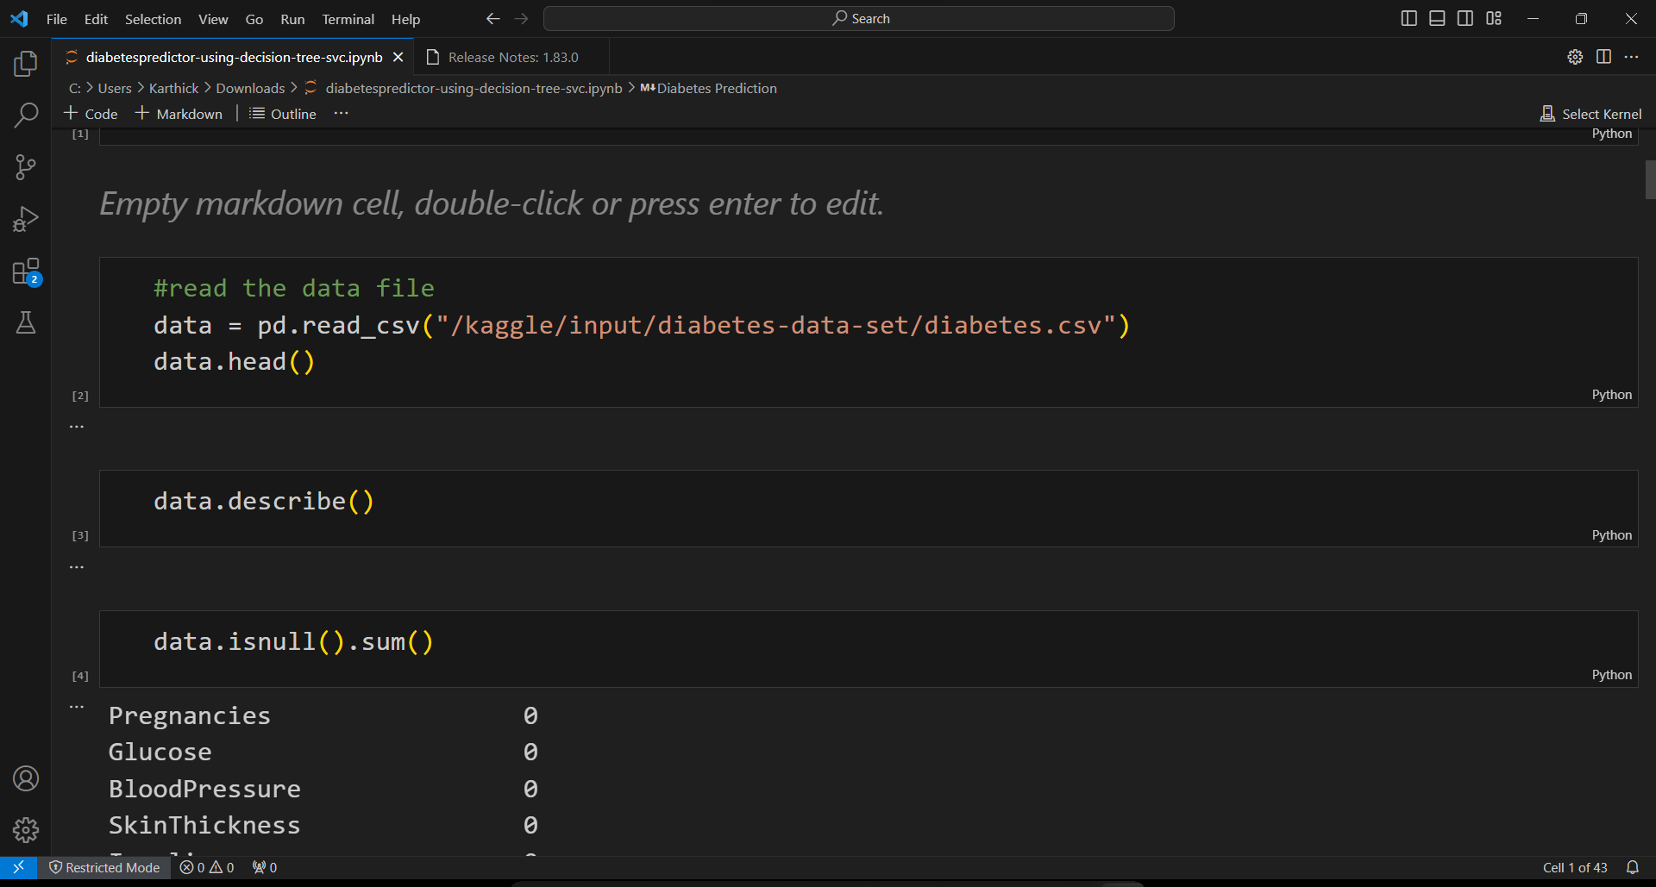

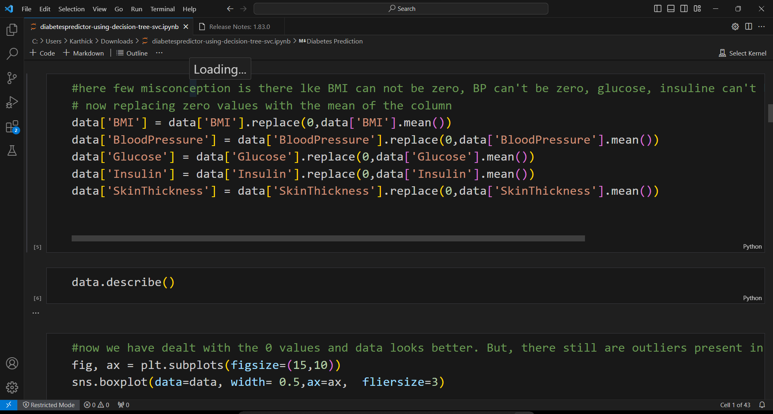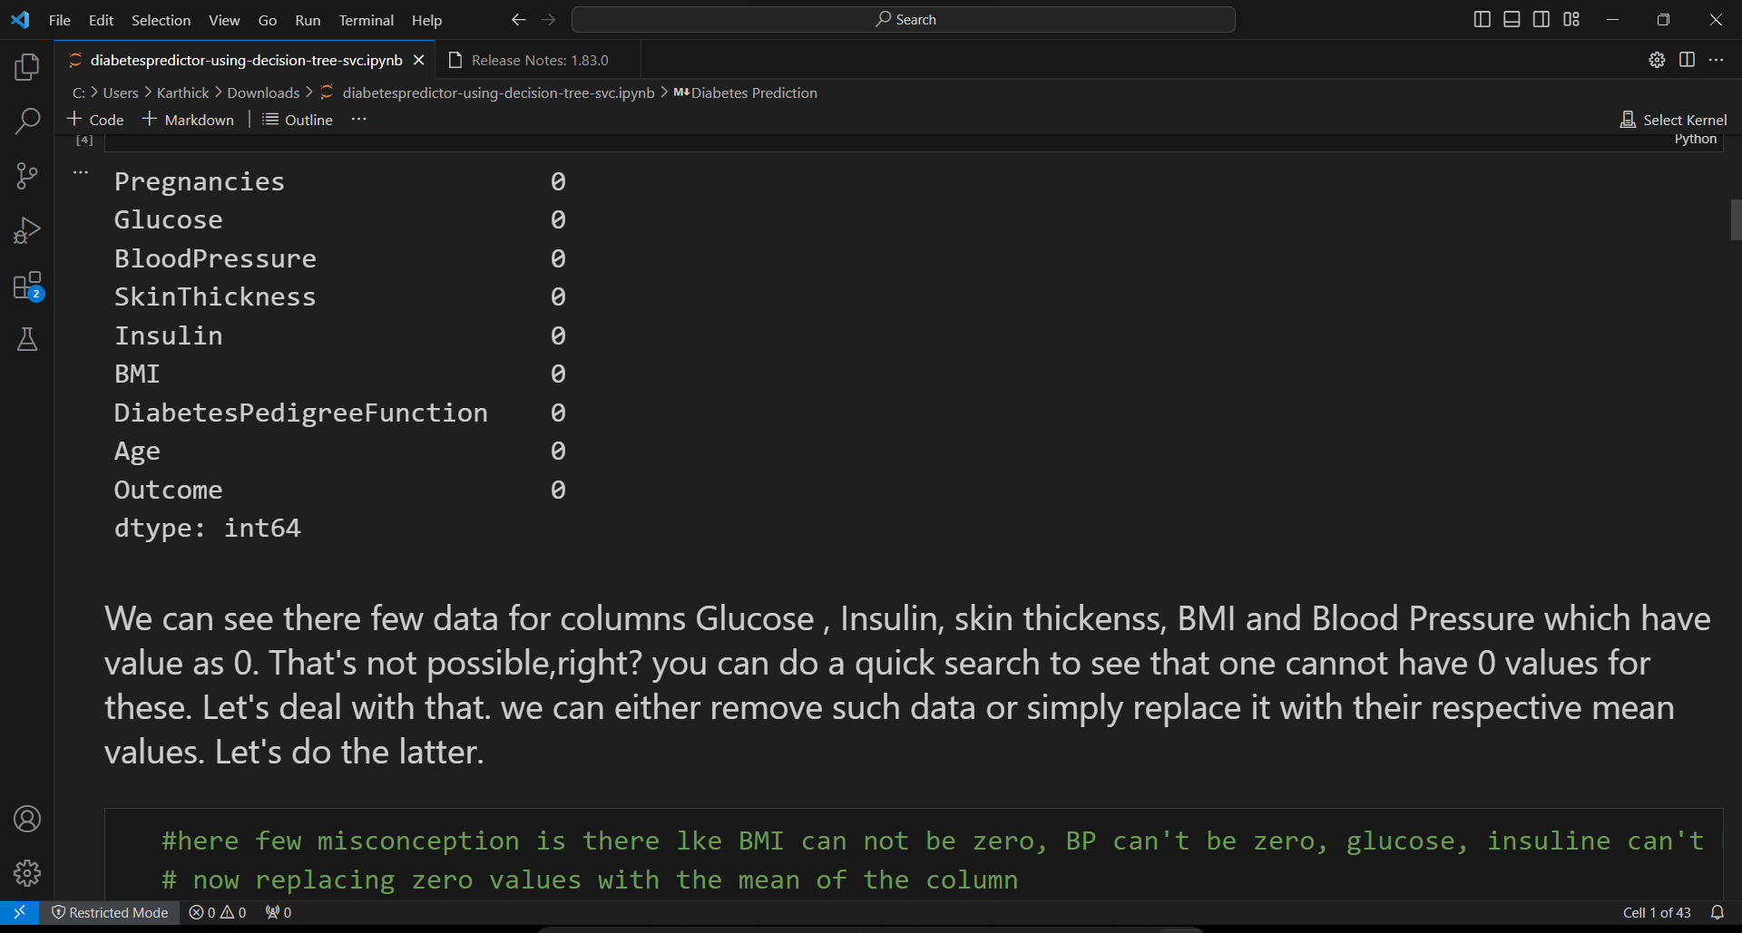

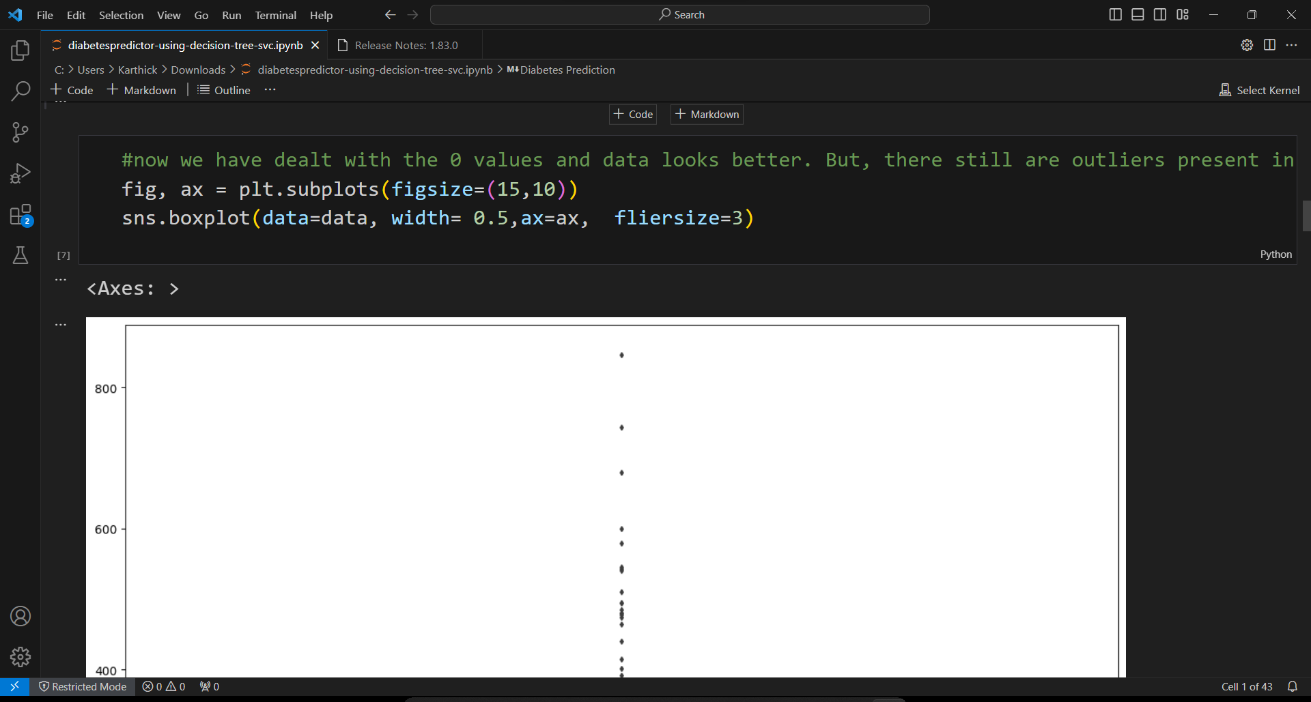

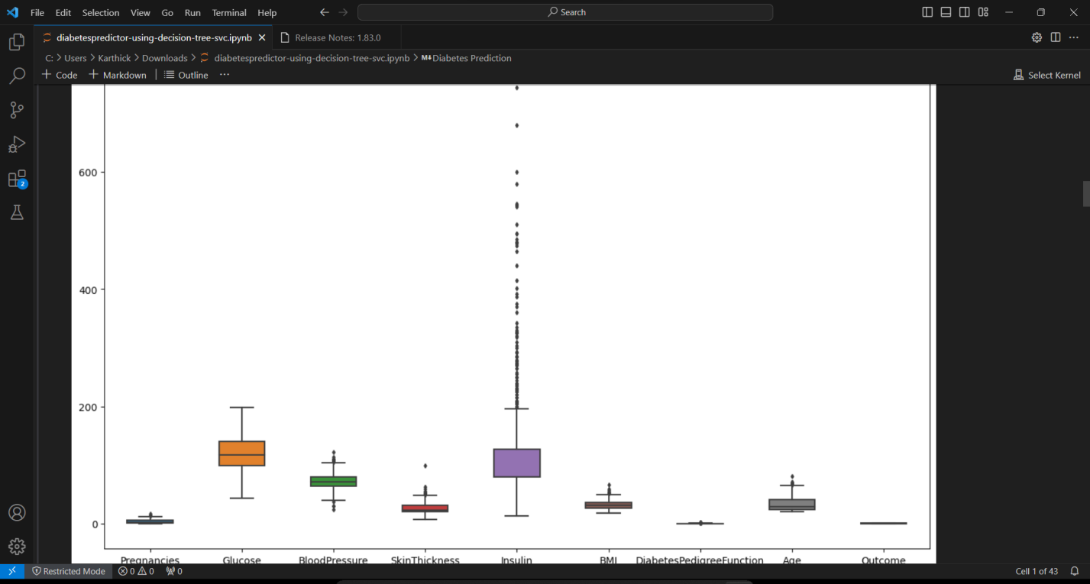

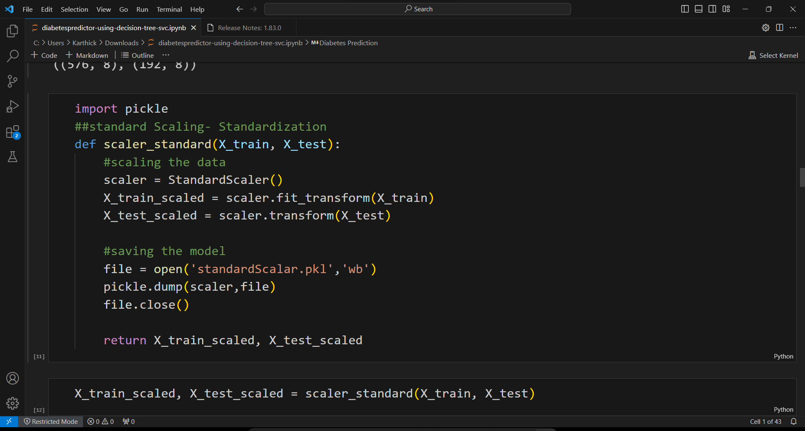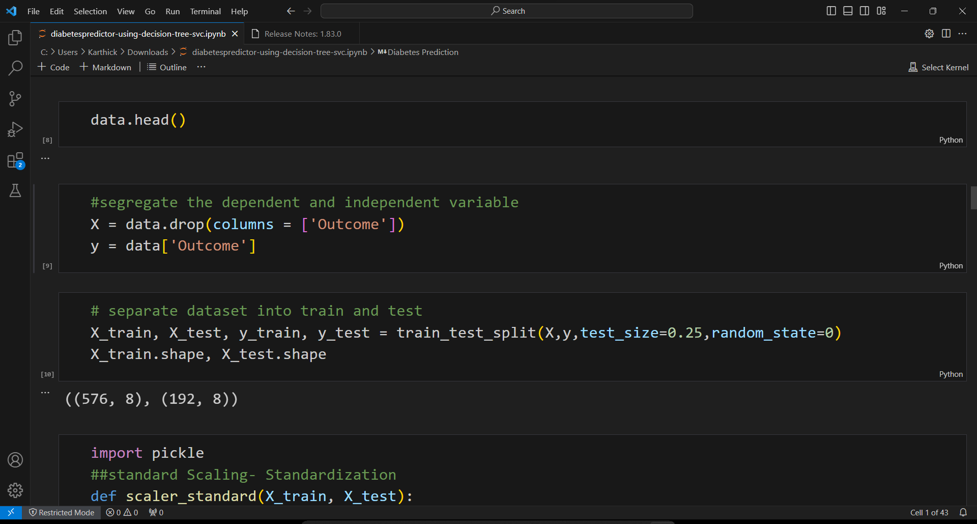

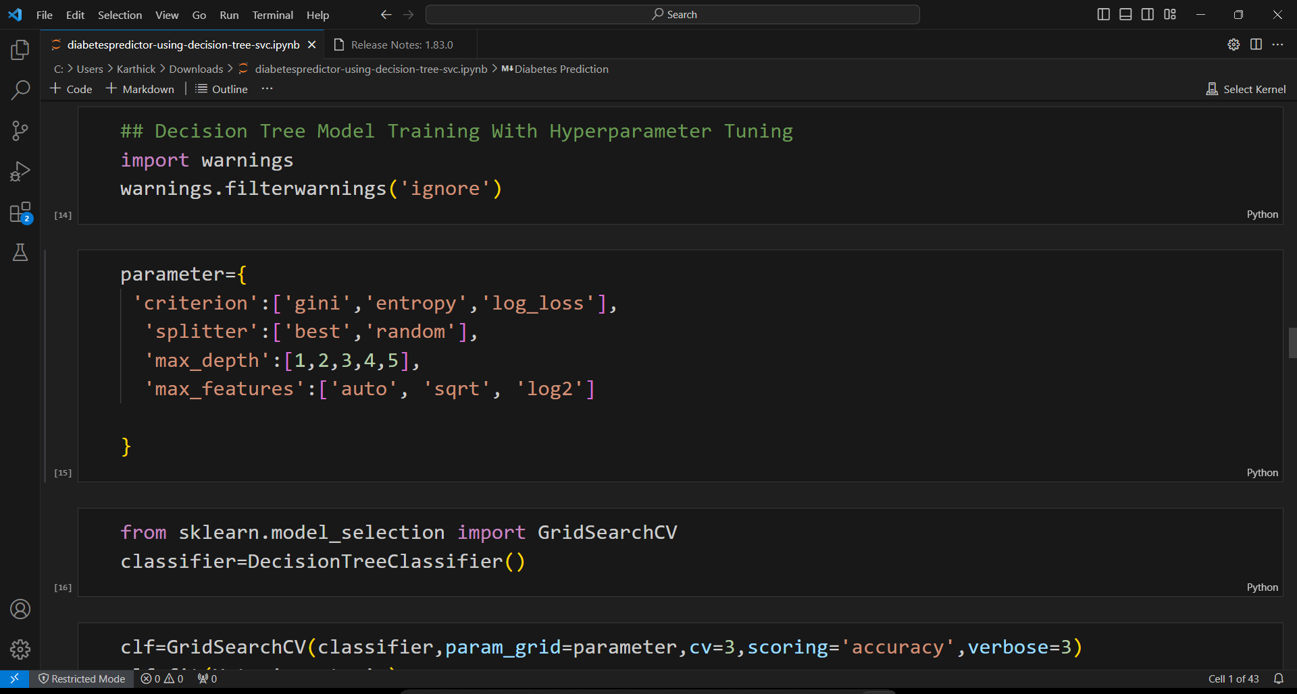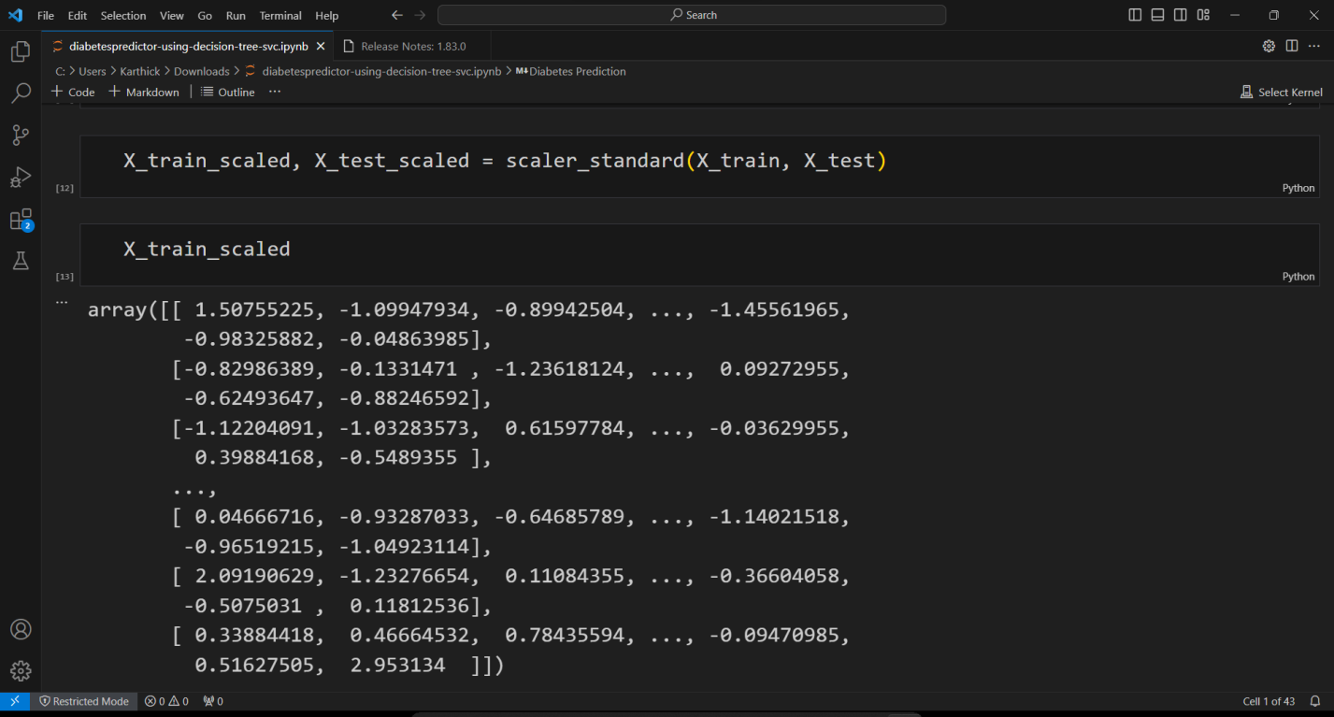

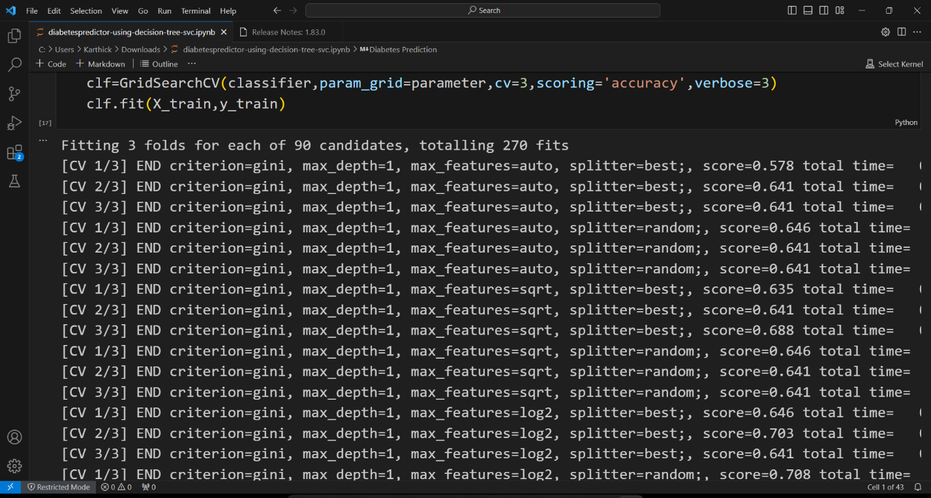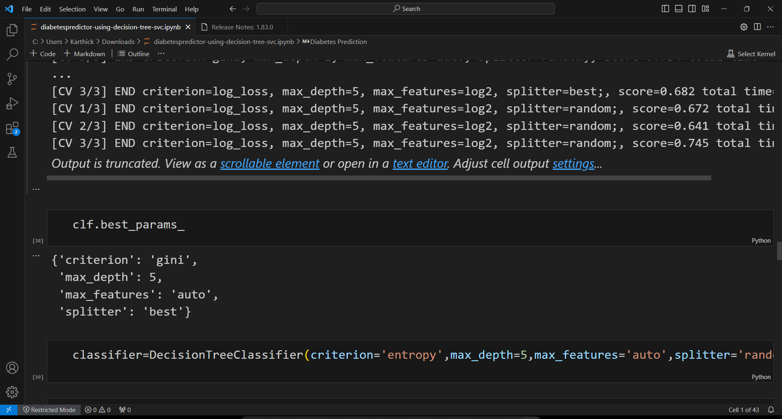

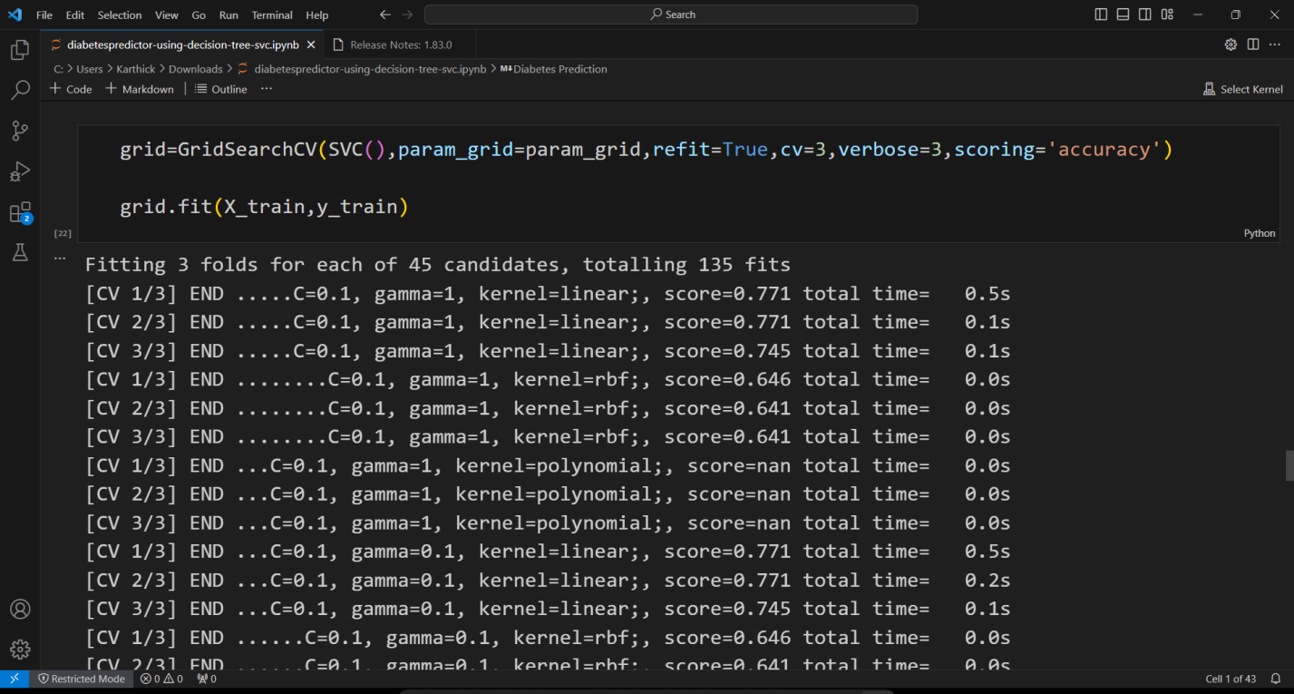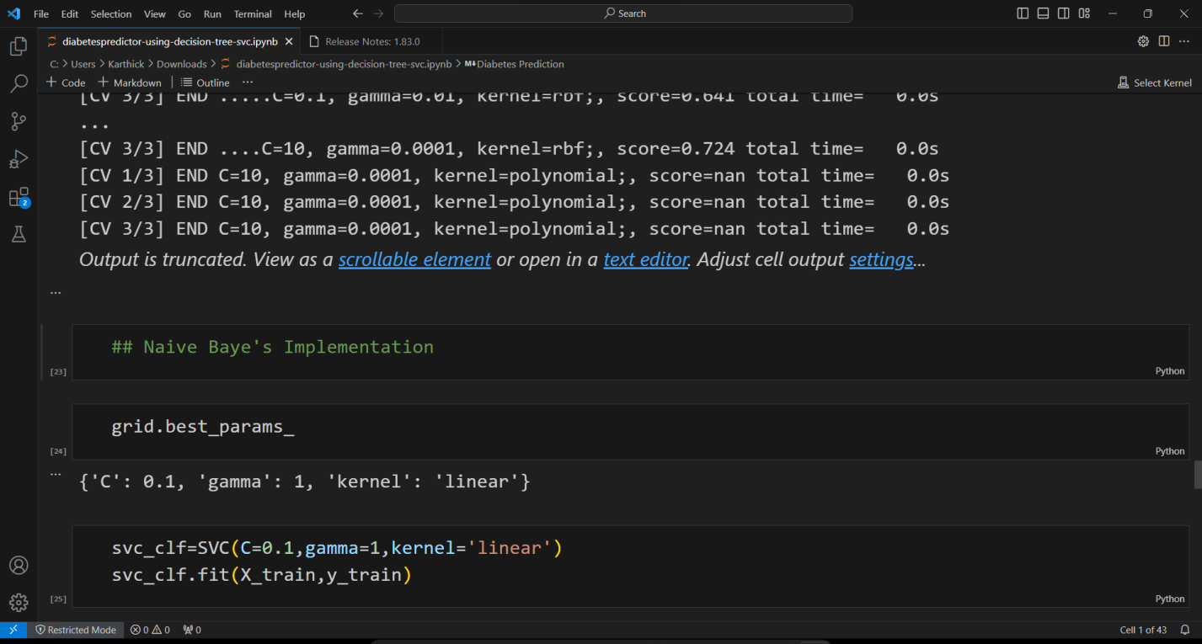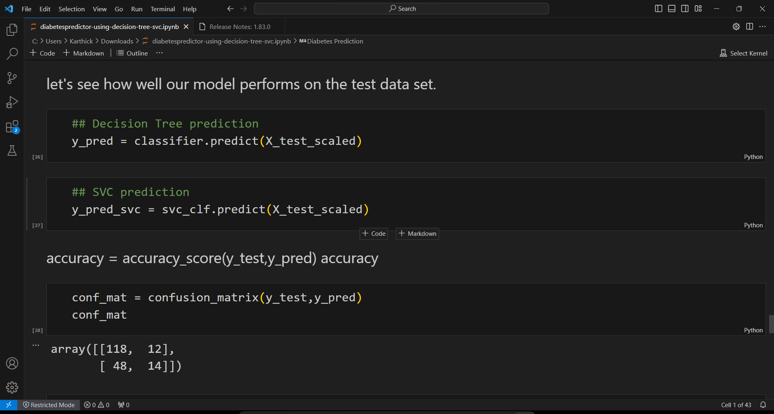

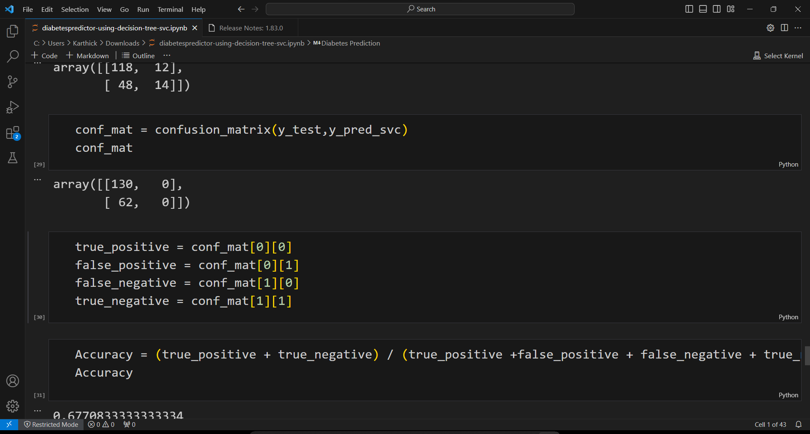

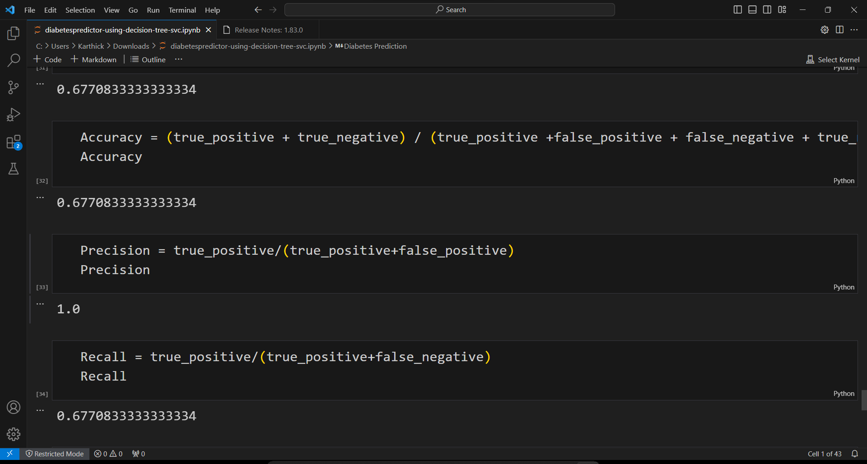

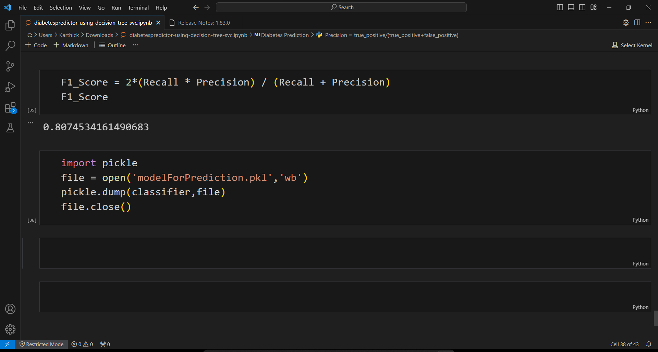

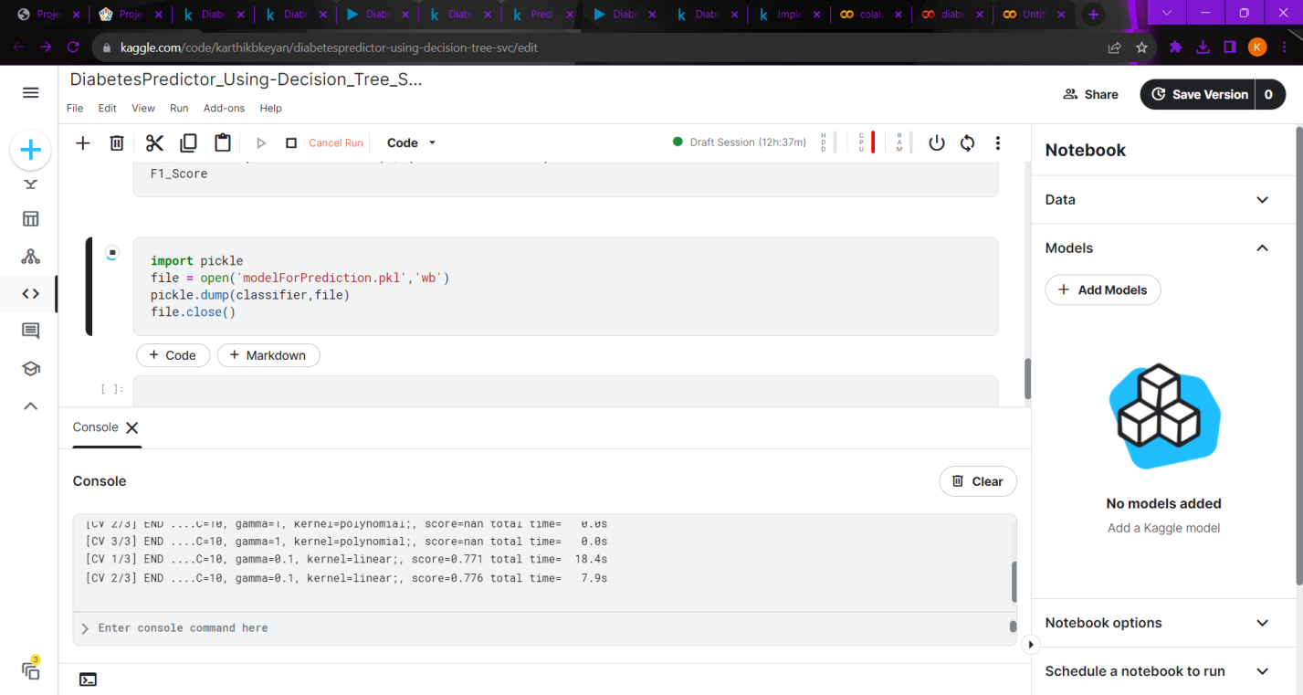

**OUTPUT:**

[CV 2/3] END ......C=10, gamma=1, kernel=linear;, score=0.776 total time= 7.9s

[CV 3/3] END ......C=10, gamma=1, kernel=linear;, score=0.740 total time= 5.0s

[CV 1/3] END .........C=10, gamma=1, kernel=rbf;, score=0.646 total time= 0.0s

[CV 2/3] END .........C=10, gamma=1, kernel=rbf;, score=0.641 total time= 0.0s

[CV 3/3] END .........C=10, gamma=1, kernel=rbf;, score=0.641 total time= 0.0s

**DIABETES PREDICTION USING LOGISTIC REGRESSION:**

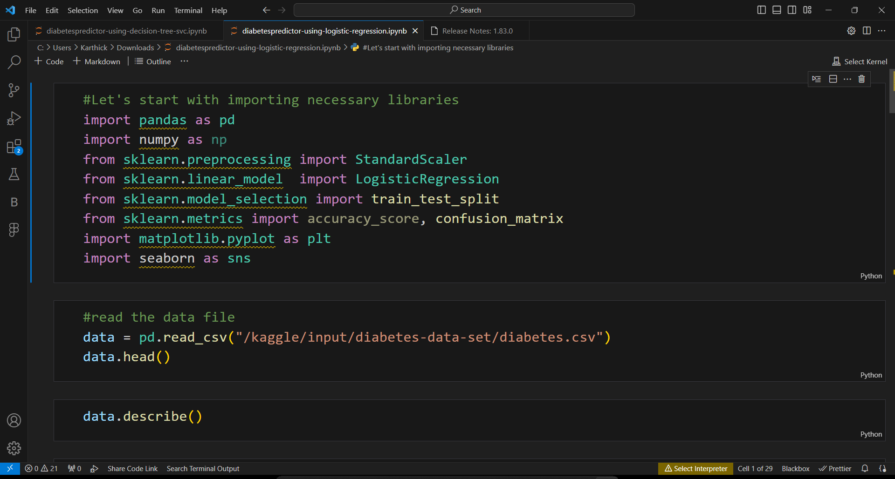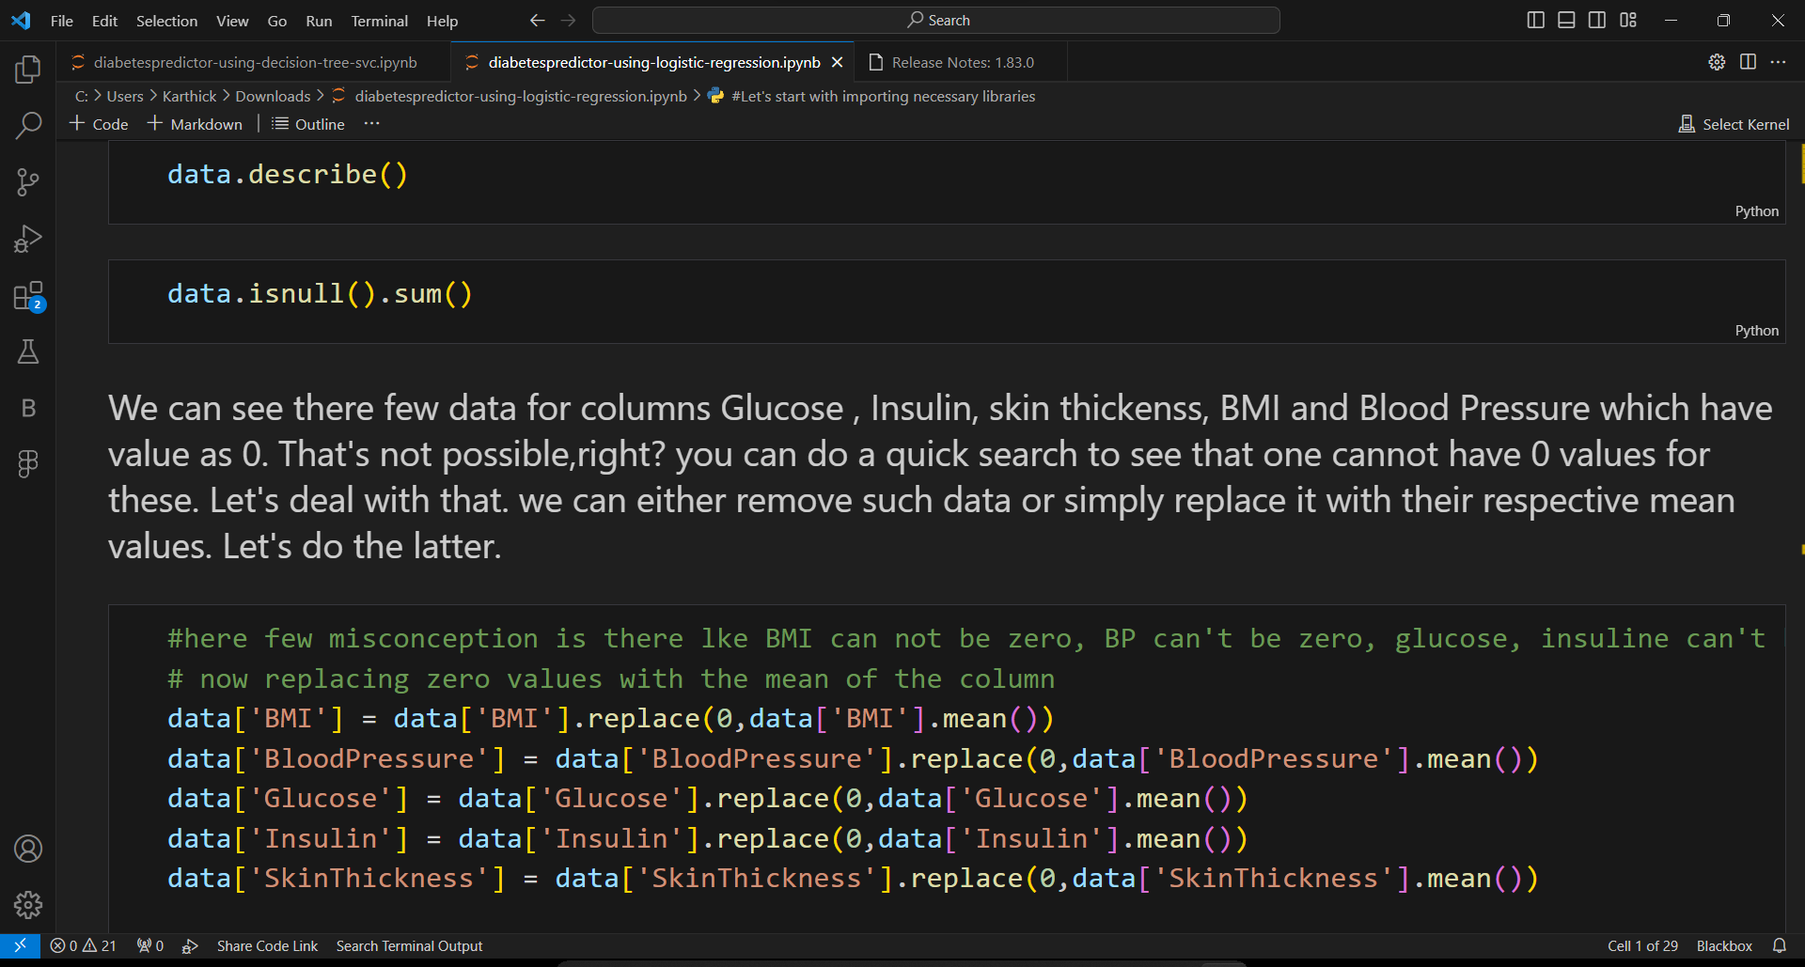

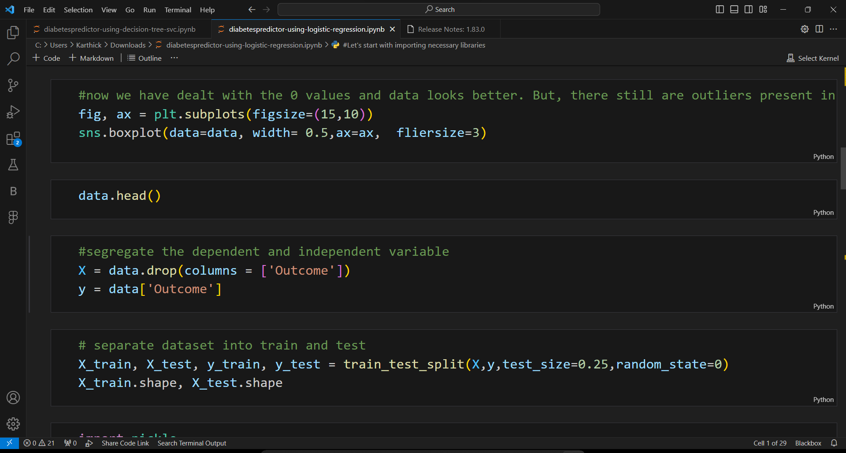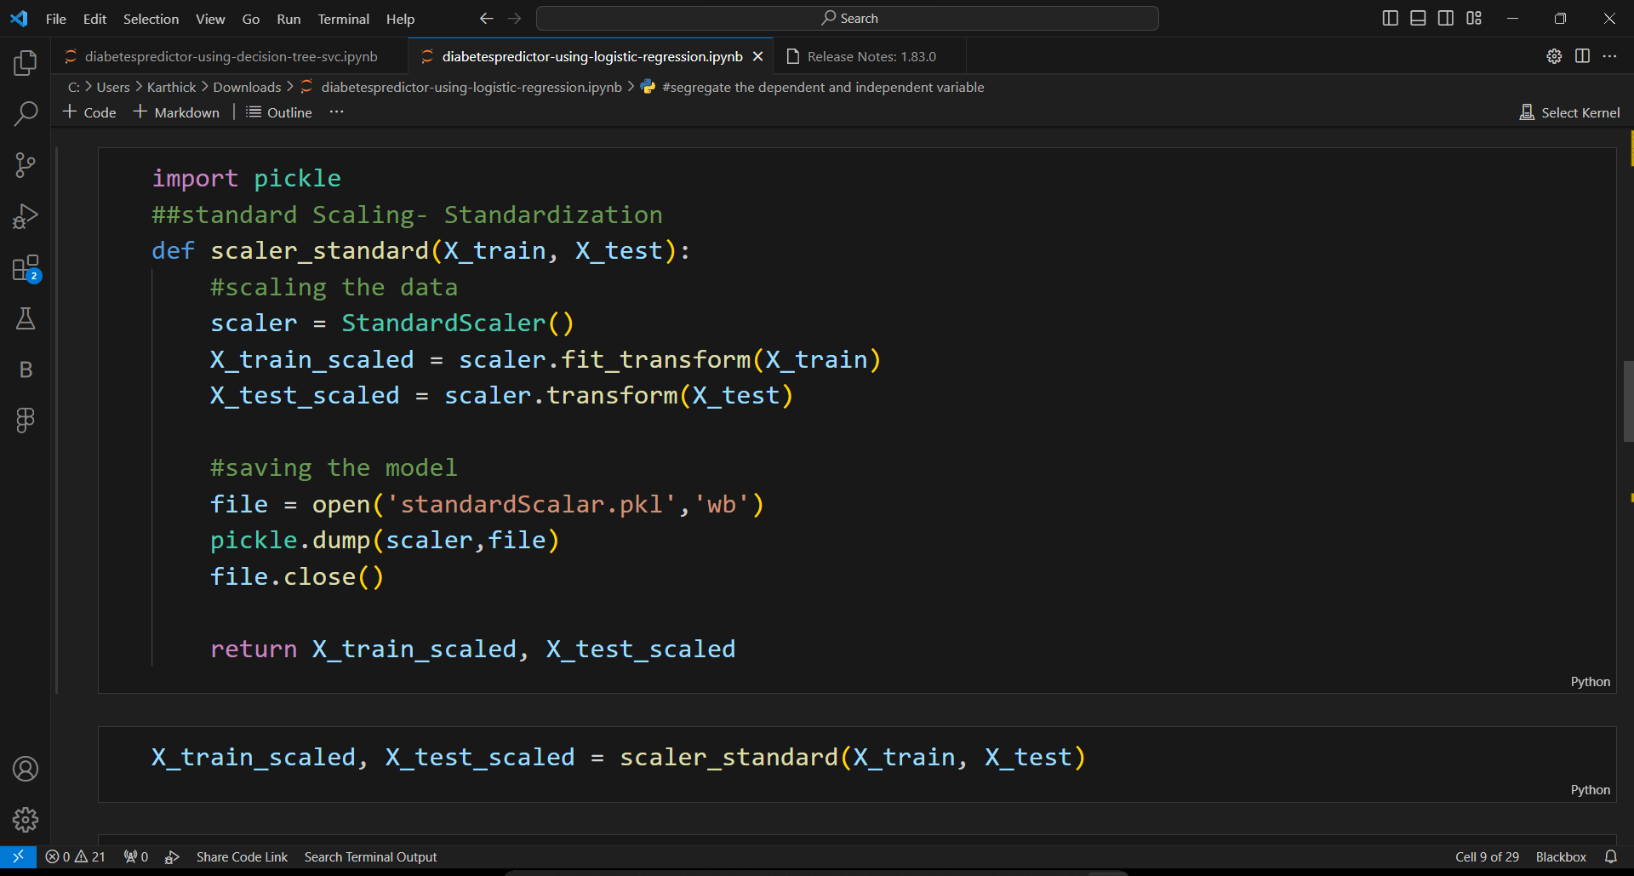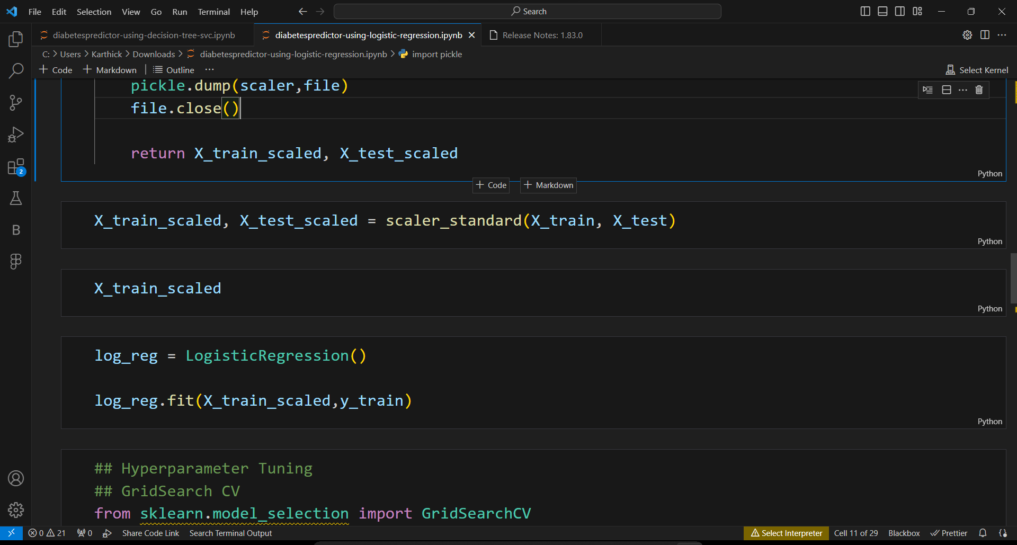

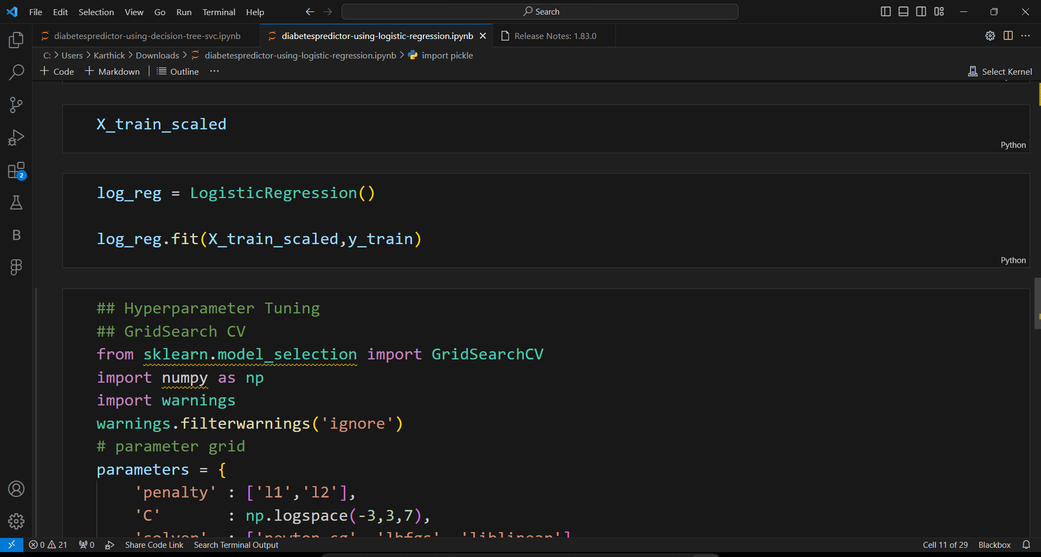

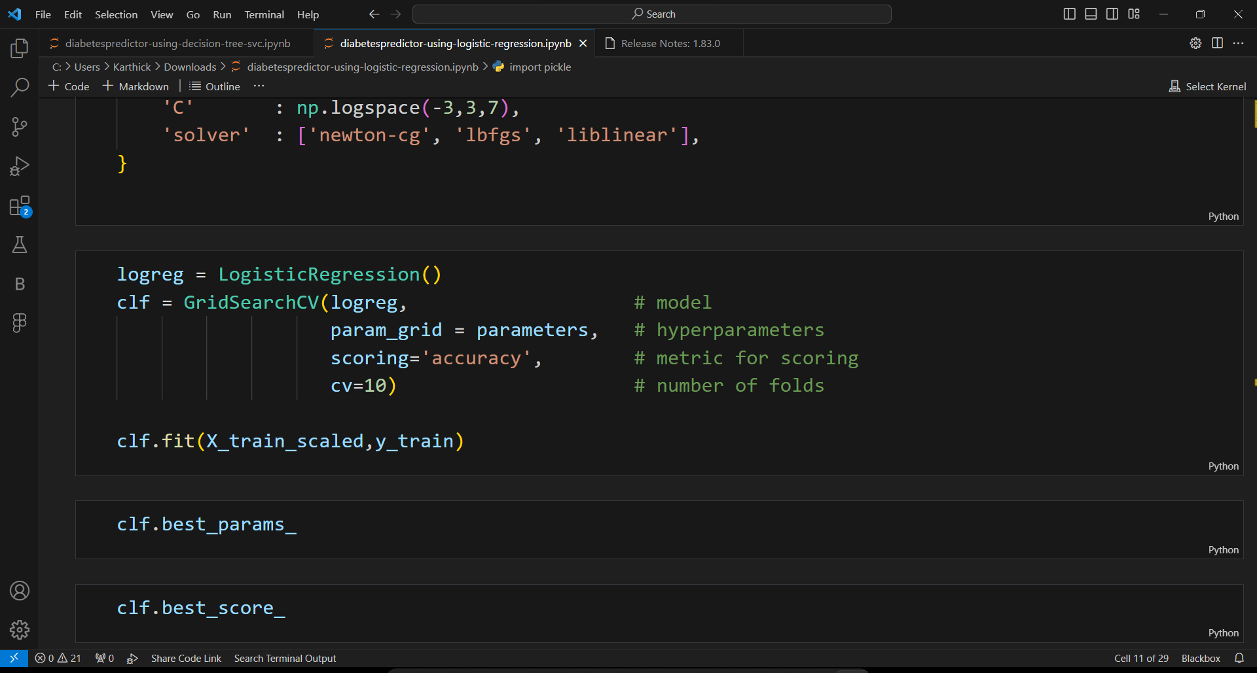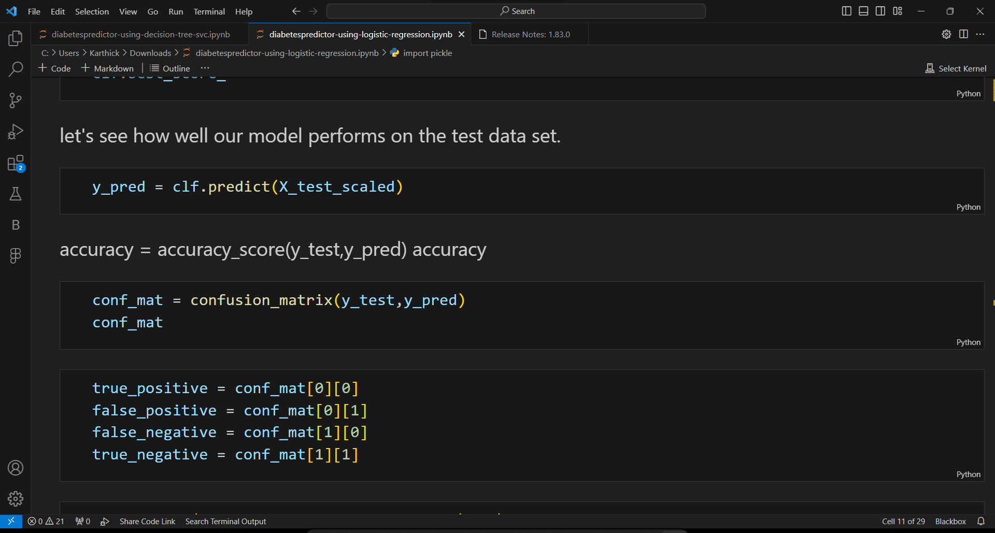

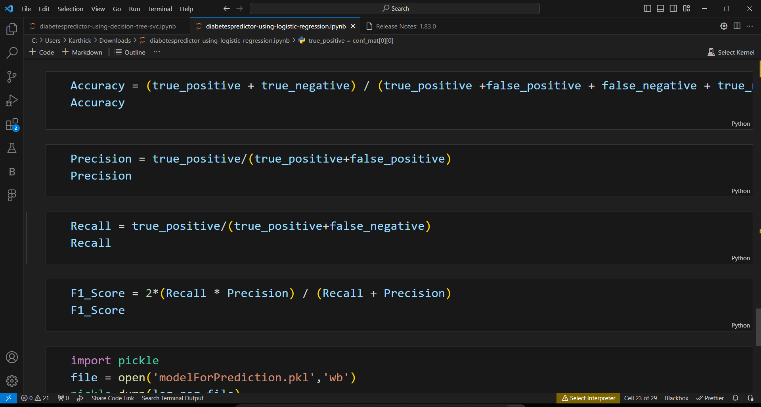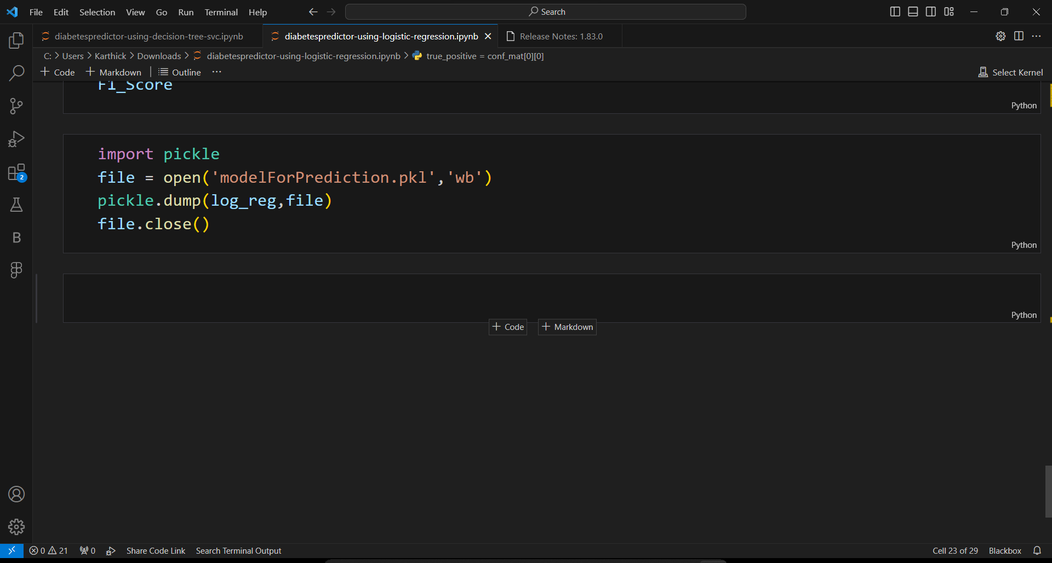

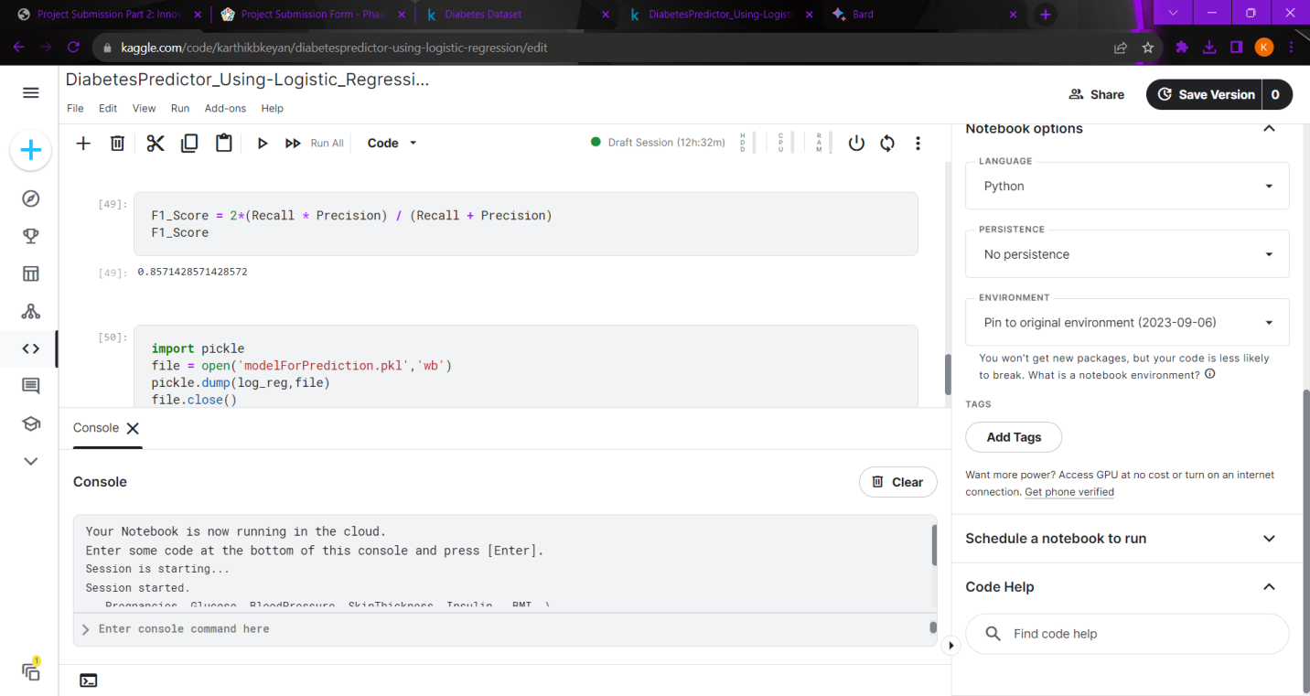

**OUTPUT:**

0.796875

0.9

0.8181818181818182

0.857142857142857

**3.BUILD LOADING AND PREPROCESSING THE DATASET**

To build, load, and preprocess the dataset for AI-based diabetes prediction, you can follow these steps:

1. Collect the dataset.

The first step is to collect a dataset of patient data that includes both features that are predictive of diabetes and the target variable, which is whether or not the patient has diabetes. There are a number of publicly available datasets that can be used for AI-based diabetes prediction, such as the Pima Indians Diabetes Database.

2. Load the dataset into a programming language.

Once you have collected the dataset, you need to load it into a programming language such as Python or R. This will allow you to perform data preprocessing and machine learning tasks.

3. Preprocess the dataset.

Before you can train an AI model, you need to preprocess the dataset. This may involve cleaning the data, removing outliers, and encoding categorical features.

Here are some specific data preprocessing steps that you may need to perform:

* Handle missing values: Missing values are a common problem in real-world datasets. You can handle missing values by removing them, imputing them with a mean or median value, or using a more sophisticated technique such as multiple imputation.
* Remove outliers: Outliers are data points that are significantly different from the rest of the data. Outliers can skew the results of machine learning models, so it is important to remove them before training a model. You can identify outliers using statistical methods or by visualizing the data.
* Encode categorical features: Machine learning models can only work with numerical data. If your dataset contains categorical features, you need to encode them into numerical values. There are a number of different ways to encode categorical features, such as one-hot encoding and label encoding.

4. Split the dataset into training and testing sets.

Once you have preprocessed the dataset, you need to split it into training and testing sets. The training set will be used to train the AI model, and the testing set will be used to evaluate the model's performance.

You can split the dataset using a variety of methods, such as random sampling or stratified sampling. Stratified sampling ensures that the training and testing sets have the same distribution of target values.

5. Build and train the AI model.

Once you have split the dataset into training and testing sets, you can build and train the AI model. There are a variety of different machine learning algorithms that you can use for AI-based diabetes prediction, such as logistic regression, support vector machines, and random forests.

The specific algorithm that you choose will depend on your specific needs and the characteristics of your dataset.

6. Evaluate the model's performance.

Once you have trained the AI model, you need to evaluate its performance on the testing set. This will give you an idea of how well the model will generalize to new data.

You can evaluate the model's performance using a variety of metrics, such as accuracy, precision, recall, and F1 score.

Once you are satisfied with the model's performance, you can deploy it to production. This may involve integrating the model into a healthcare information system or developing a mobile app that uses the model to predict diabetes risk.

By following these steps, you can build a robust and effective AI-based diabetes prediction system.

**PROGRAMS**

**DATA CLEANING:**

*#importing libraries*

import pandas as pd

import numpy as np

import matplotlib.pyplot as plt

import seaborn as sns

*#read dataset*

df=pd.read_csv('../input/diabetes

-data-set/diabetes.csv')

### EDA

df.head()

| Pregnancies | Glucose | BloodPressure | SkinThickness | Insulin | BMI | DiabetesPedigreeFunction | Age | Outcome |
| --- | --- | --- | --- | --- | --- | --- | --- | --- |
| 0 | 6 | 148 | 72 | 35 | 0 | 33.6 | 0.627 | 50 | 1 |
| 1 | 1 | 85 | 66 | 29 | 0 | 26.6 | 0.351 | 31 | 0 |
| 2 | 8 | 183 | 64 | 0 | 0 | 23.3 | 0.672 | 32 | 1 |
| 3 | 1 | 89 | 66 | 23 | 94 | 28.1 | 0.167 | 21 | 0 |
| 4 | 0 | 137 | 40 | 35 | 168 | 43.1 | 2.288 | 33 | 1 |
|  |  |  |  |  |  |  |  |  |  |

df.columns

Index(['Pregnancies', 'Glucose', 'BloodPressure', 'SkinThickness', 'Insulin',

'BMI', 'DiabetesPedigreeFunction', 'Age', 'Outcome'],

dtype='object')

df.info()

<class 'pandas.core.frame.DataFrame'>

RangeIndex: 768 entries, 0 to 767

Data columns (total 9 columns):

# Column Non-Null Count Dtype

--- ------ -------------- -----

0 Pregnancies 768 non-null int64

1 Glucose 768 non-null int64

2 BloodPressure 768 non-null int64

3 SkinThickness 768 non-null int64

4 Insulin 768 non-null int64

5 BMI 768 non-null float64

6 DiabetesPedigreeFunction 768 non-null float64

7 Age 768 non-null int64

8 Outcome 768 non-null int64

dtypes: float64(2), int64(7)

memory usage: 54.1 KB

df.shape

(768, 9)

In [7]:

linkcode

df.describe()

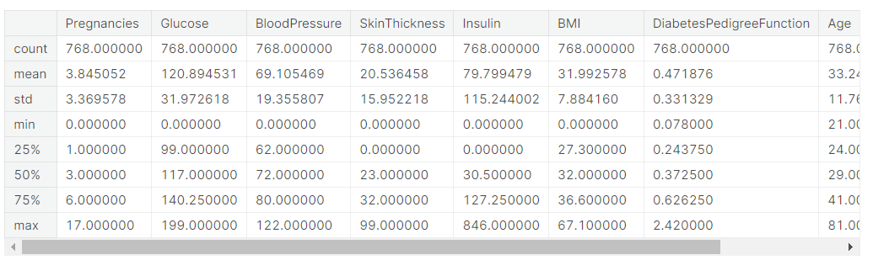

*#checking null values*

df.isnull().sum()

Pregnancies 0

Glucose 0

BloodPressure 0

SkinThickness 0

Insulin 0

BMI 0

DiabetesPedigreeFunction 0

Age 0

Outcome 0

dtype: int64

*#countplot*

sns.countplot(x='Outcome',data=df,palette=['b','g'])

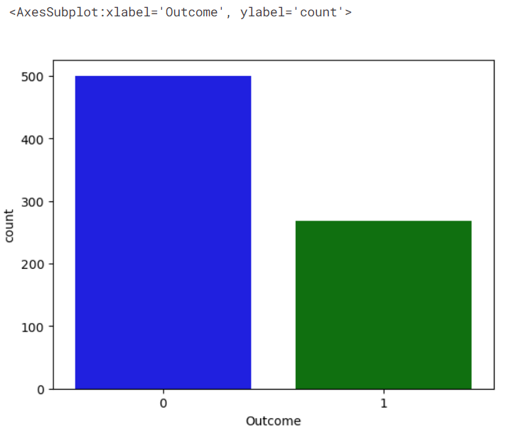

*#pairplot*

sns.pairplot(data=df,hue='Outcome')

plt.show()

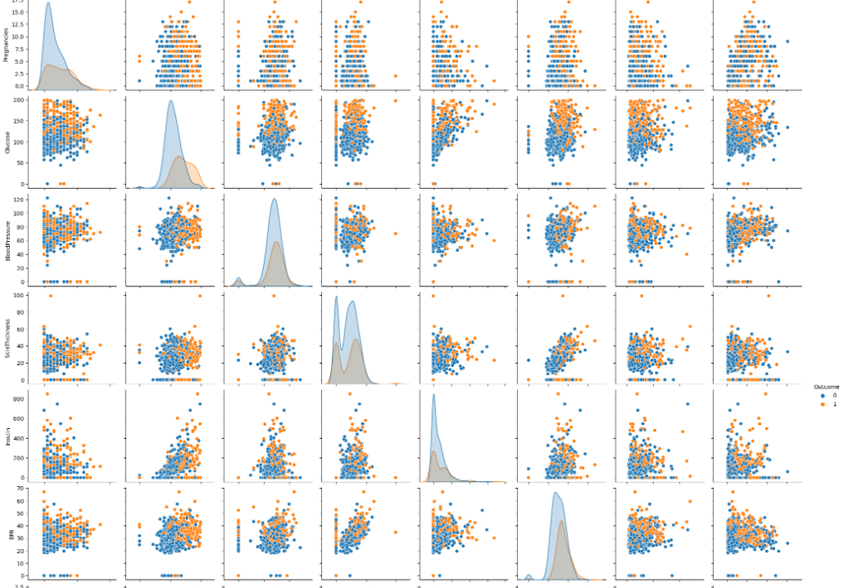

*#correlation heatmap*

sns.heatmap(df.corr(),annot=True,cmap='Blues')

plt.show()

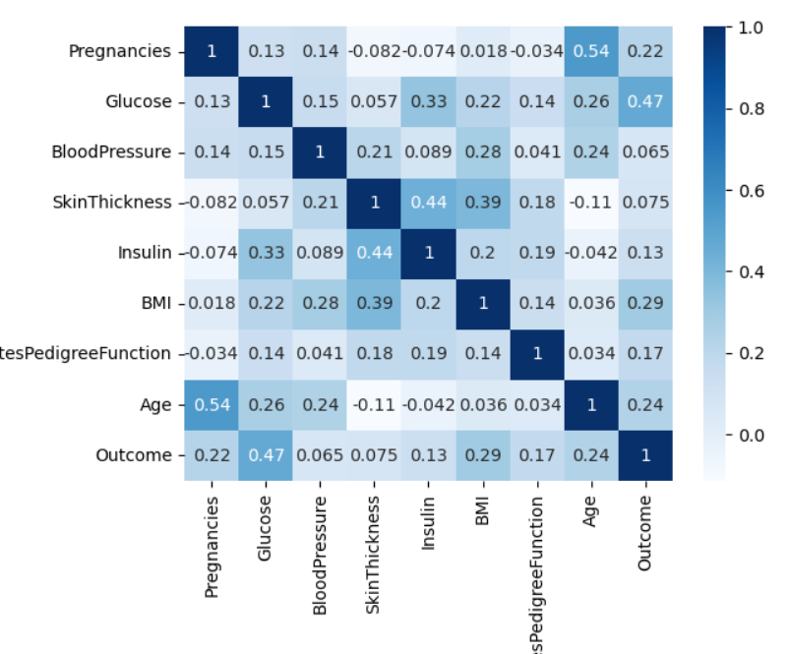

*#replacing zero value with NaN*

df_new=df

df_new[["Glucose", "BloodPressure", "SkinThickness", "Insulin", "BMI"]] = df_new[["Glucose", "BloodPressure", "SkinThickness", "Insulin", "BMI"]].replace(0, np.NaN)

In [13]:

*#count of Nan*

df_new.isnull().sum()

Out[13]:

Pregnancies 0

Glucose 5

BloodPressure 35

SkinThickness 227

Insulin 374

BMI 11

DiabetesPedigreeFunction 0

Age 0

Outcome 0

dtype: int64

*#replacing NaN with mean values*

df_new["Glucose"].fillna(df_new["Glucose"].mean(), inplace = True)

df_new["BloodPressure"].fillna(df_new["BloodPressure"].mean(), inplace = True)

df_new["SkinThickness"].fillna(df_new["SkinThickness"].mean(), inplace = True)

df_new["Insulin"].fillna(df_new["Insulin"].mean(), inplace = True)

df_new["BMI"].fillna(df_new["BMI"].mean(), inplace = True)

In [15]:

*#checking null values*

df_new.isnull().sum()

Out[15]:

Pregnancies 0

Glucose 0

BloodPressure 0

SkinThickness 0

Insulin 0

BMI 0

DiabetesPedigreeFunction 0

Age 0

Outcome 0

dtype: int64

y=df_new['Outcome']

X=df_new.drop('Outcome',axis=1)

In [17]:

linkcode

*#spliting X and y*

from sklearn.model_selection import train_test_split

X_train,X_test,Y_train,Y_test=train_test_split(X,y,test_size=0.20,random_state=0,stratify=df_new['Outcome'])

from sklearn.linear_model import LogisticRegression

model=LogisticRegression()

model.fit(X_train,Y_train)

/opt/conda/lib/python3.7/site-packages/sklearn/linear_model/_logistic.py:818: ConvergenceWarning: lbfgs failed to converge (status=1):

STOP: TOTAL NO. of ITERATIONS REACHED LIMIT.

Increase the number of iterations (max_iter) or scale the data as shown in:

https://scikit-learn.org/stable/modules/preprocessing.html

Please also refer to the documentation for alternative solver options:

https://scikit-learn.org/stable/modules/linear_model.html#logistic-regression

extra_warning_msg=_LOGISTIC_SOLVER_CONVERGENCE_MSG,

LogisticRegression()

In [19]:

*#get prediction*

y_predict=model.predict(X_test)

y_predict

Out[19]:

array([0, 0, 0, 0, 1, 0, 1, 0, 0, 0, 0, 0, 0, 0, 0, 0, 0, 0, 0, 1, 0, 1,

0, 0, 0, 1, 1, 0, 0, 0, 0, 0, 1, 0, 1, 0, 1, 0, 0, 1, 0, 0, 1, 0,

1, 1, 0, 0, 0, 0, 0, 0, 0, 1, 0, 0, 0, 0, 0, 0, 0, 0, 1, 0, 0, 0,

0, 0, 0, 0, 0, 0, 0, 0, 1, 0, 0, 0, 0, 1, 0, 0, 1, 0, 1, 1, 0, 0,

1, 0, 0, 0, 0, 1, 1, 0, 0, 1, 0, 0, 0, 0, 0, 0, 0, 0, 0, 1, 0, 0,

0, 0, 0, 1, 0, 0, 0, 0, 0, 0, 1, 0, 1, 0, 0, 0, 0, 1, 0, 0, 0, 1,

0, 1, 0, 1, 1, 0, 1, 1, 0, 0, 1, 0, 0, 1, 0, 0, 1, 0, 0, 1, 0, 0])

In [20]:

linkcode

*#confusion matrix*

from sklearn.metrics import confusion_matrix

cm=confusion_matrix(Y_test,y_predict)

cm

Out[20]:

array([[89, 11],

[26, 28]])

In [21]:

linkcode

*#heatmap of confusion matrix*

sns.heatmap(pd.DataFrame(cm),annot=True, cmap="Greens")

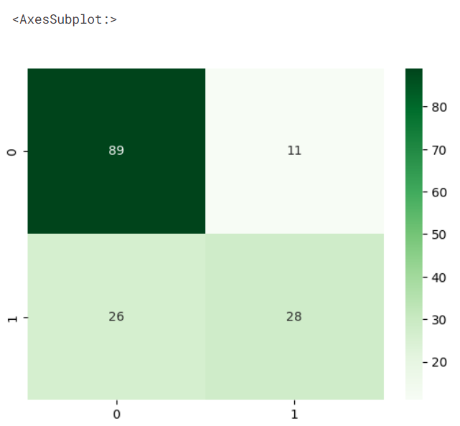

*#accuracy score*

from sklearn.metrics import accuracy_score

accuracy=accuracy_score(Y_test,y_predict)

print("Accuracy : ",round(accuracy,2)*100,'%')

**ACCURACY:**

**76.0%**

Diabetes is a chronic disease that affects how your body turns food into energy. With diabetes, your body either resists the effects of insulin—a hormone that regulates the movement of sugar into your cells—or doesn't produce enough insulin to maintain normal glucose levels.

Early detection and treatment of diabetes can help prevent serious health complications, such as heart disease, stroke, blindness, and kidney disease. Machine learning algorithms can be used to predict diabetes risk based on a variety of factors, including age, gender, family history, medical history, and lifestyle habits.

Selecting a machine learning algorithm

There are many different machine learning algorithms that can be used to predict diabetes. Some of the most common algorithms include:

* Logistic regression: A simple but effective algorithm for predicting binary outcomes, such as whether or not someone has diabetes.
* Support vector machines (SVM): A more complex algorithm that can be used to predict both binary and continuous outcomes.
* Random forests: An ensemble learning algorithm that combines the predictions of multiple decision trees to produce a more accurate prediction.
* Deep neural networks: A type of artificial intelligence that can learn complex patterns in data.

The best machine learning algorithm to use for diabetes prediction will depend on the specific dataset being used and the desired performance metrics.

Training the model

Once a machine learning algorithm has been selected, it needs to be trained on a dataset of labeled examples. Labeled examples are data points where the target variable (in this case, whether or not someone has diabetes) is known.

The training process involves feeding the algorithm the labeled examples and allowing it to learn the relationship between the input features (e.g., age, gender, medical history) and the target variable.

Evaluating the performance of the model

Once the model has been trained, it needs to be evaluated on a held-out test set. The test set is a dataset of labeled examples that was not used to train the model.

Evaluating the model on the test set provides an estimate of how well the model will perform on new data. Common performance metrics for diabetes prediction include accuracy, precision, recall, and F1 score.

Machine learning algorithms can be used to predict diabetes risk with high accuracy. By predicting diabetes risk, clinicians can identify people who are at high risk and provide them with early intervention and preventive care.

Here are some additional tips for selecting, training, and evaluating a machine learning model for diabetes prediction:

* Use a variety of features. The more features you use to train your model, the more accurate it will be. However, it is important to select features that are relevant to diabetes prediction and to avoid overfitting the model to the training data.
* Use cross-validation. Cross-validation is a technique that allows you to evaluate the performance of your model on multiple datasets. This is important to avoid overfitting the model to the training data.
* Tune the hyperparameters. Hyperparameters are parameters that control the behavior of the machine learning algorithm. Tuning the hyperparameters can improve the performance of the model.
* Use a variety of evaluation metrics. Accuracy is a common evaluation metric, but it is important to also consider other metrics, such as precision, recall, and F1 score. This is because accuracy can be misleading in some cases, such as when the dataset is imbalanced.

Once you have selected, trained, and evaluated your model, you can use it to predict diabetes risk in new patients. This information can be used to guide clinical decision-making and to provide patients with personalized recommendations for prevention and care.

**OVERVIEW OF THE PROCESS:**

Overview of the Process

To select a machine learning algorithm for diabetes prediction, you need to consider the following factors:

* Type of data: Is your data structured or unstructured? What are the features of your data?
* Complexity of the problem: How complex is the relationship between the features of your data and the target variable (i.e., whether or not a patient has diabetes)?
* Interpretability: How important is it to be able to interpret how the model makes its predictions?
* Computational resources: How much computational power do you have available?

Once you have considered these factors, you can start to narrow down your choices of machine learning algorithms. Some popular algorithms for diabetes prediction include:

* Logistic regression: A simple but effective algorithm for binary classification tasks.
* Support vector machines (SVMs): A powerful algorithm that can learn complex relationships between features and the target variable.
* Random forests: An ensemble learning algorithm that builds multiple decision trees and averages their predictions to produce a final prediction.
* Gradient boosting machines (GBMs): Another ensemble learning algorithm that builds sequential models to improve the performance of the previous model.
* Deep neural networks (DNNs): A type of machine learning model that can learn complex patterns from data.

Once you have selected a machine learning algorithm, you need to train the model on your data. This involves feeding the model your data and allowing it to learn the relationships between the features and the target variable.

Once the model is trained, you need to evaluate its performance on a held-out test set. This will give you an idea of how well the model will generalize to new data. If the model performs well on the test set, you can deploy it to production.

**Step-by-Step Procedure:**

To train a machine learning model for diabetes prediction, you can follow these steps:

1. Prepare your data. This includes cleaning the data, handling missing values, and converting categorical variables to numerical variables.
2. Split your data into training and test sets. The training set will be used to train the model, and the test set will be used to evaluate the model's performance.
3. Choose a machine learning algorithm. Consider the factors mentioned above when choosing an algorithm.
4. Train the model. Feed the training data to the model and allow it to learn the relationships between the features and the target variable.
5. Evaluate the model. Evaluate the model's performance on the test set.
6. Deploy the model. If the model performs well on the test set, you can deploy it to production.

Here is an example of how to train a random forest model for diabetes prediction using the Python programming language:

Python

import numpy as np

import pandas as pd

from sklearn.model_selection import train_test_split

from sklearn.ensemble import RandomForestClassifier

# Load the data

data = pd.read_csv("diabetes.csv")

# Split the data into training and test sets

X_train, X_test, y_train, y_test = train_test_split(data.drop(columns=["Outcome"]), data["Outcome"], test_size=0.25)

# Create the random forest model

model = RandomForestClassifier()

# Train the model

model.fit(X_train, y_train)

# Evaluate the model

y_pred = model.predict(X_test)

accuracy = np.mean(y_pred == y_test)

print("Accuracy:", accuracy)

# Deploy the model

# Save the model to a file or deploy it to a web service

This is just a basic example, and you may need to adjust the parameters of the random forest model or try other algorithms to get the best results.

**PROGRAMS:**

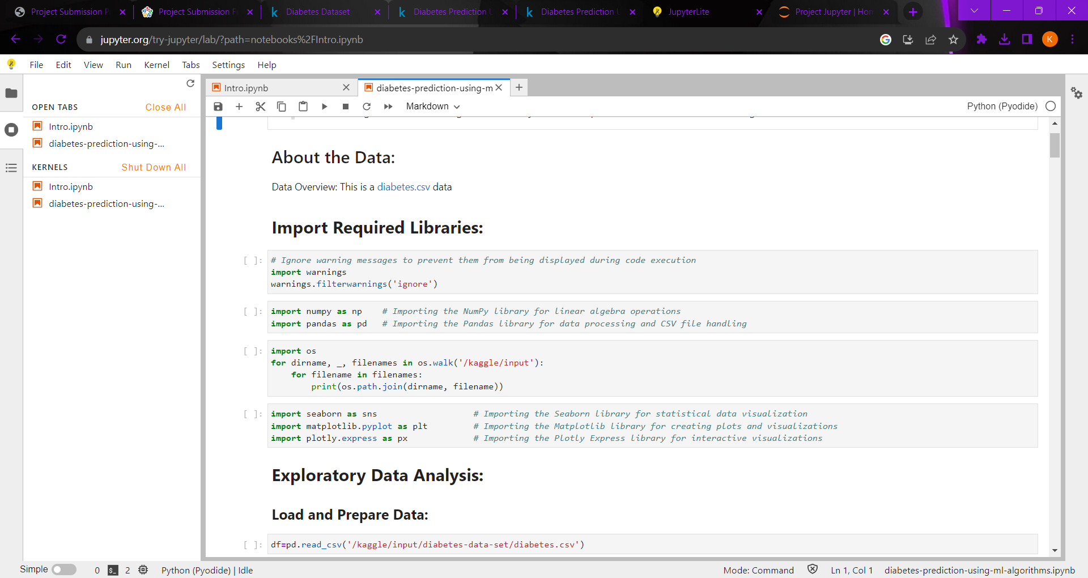

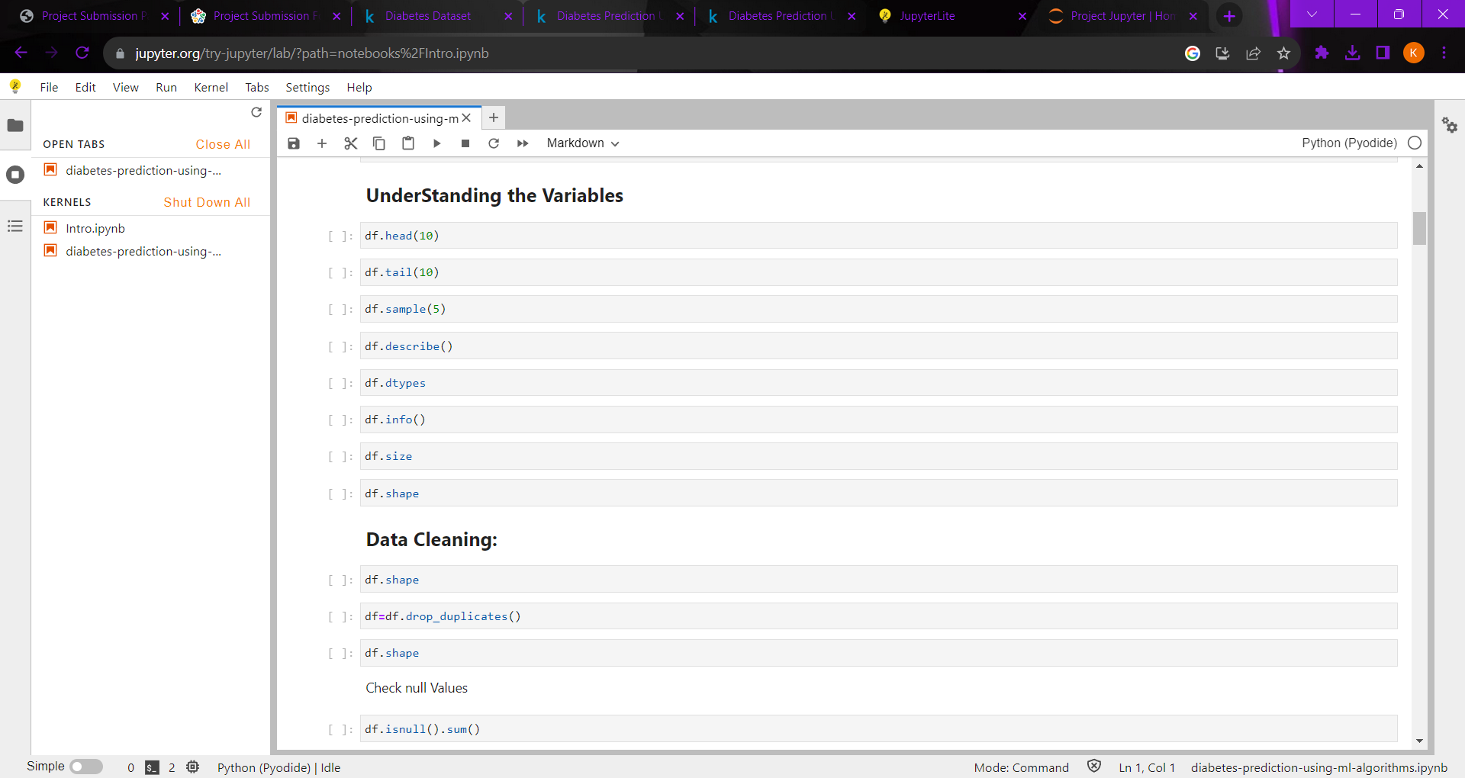

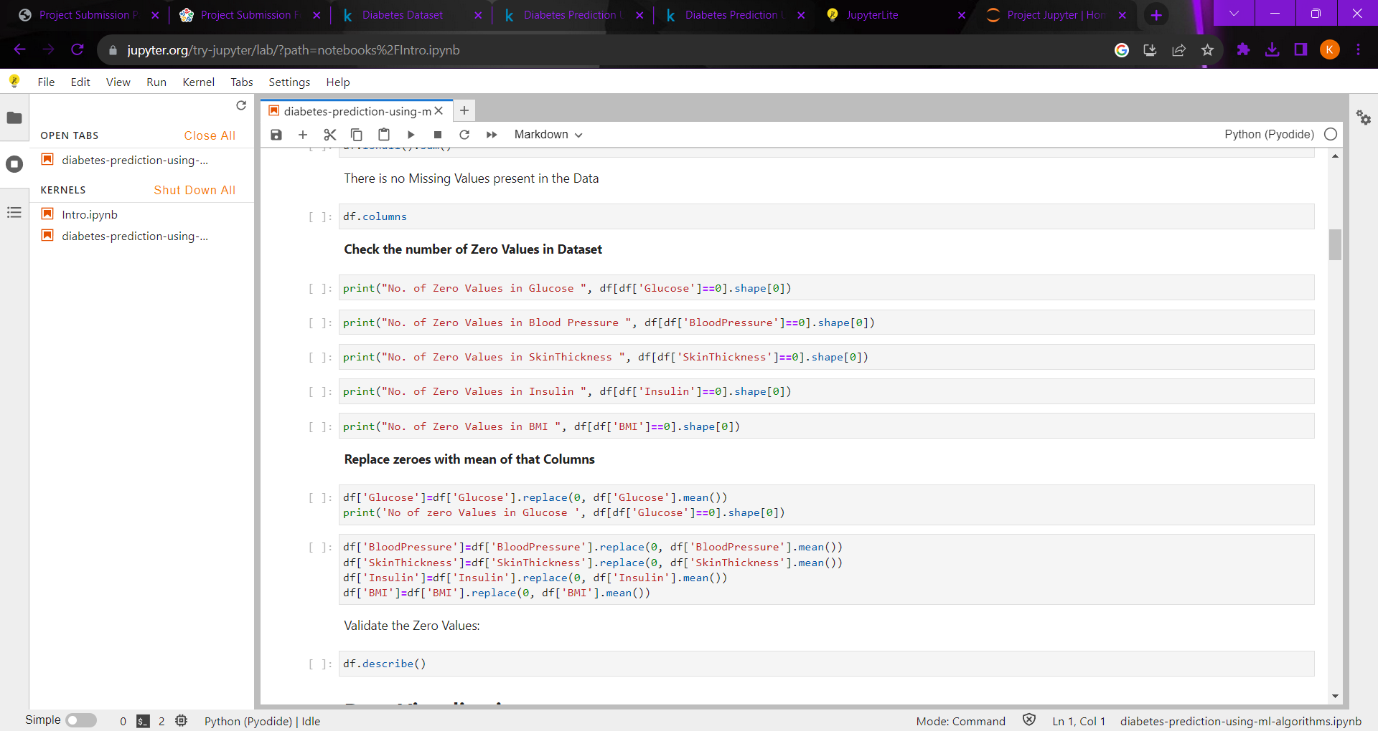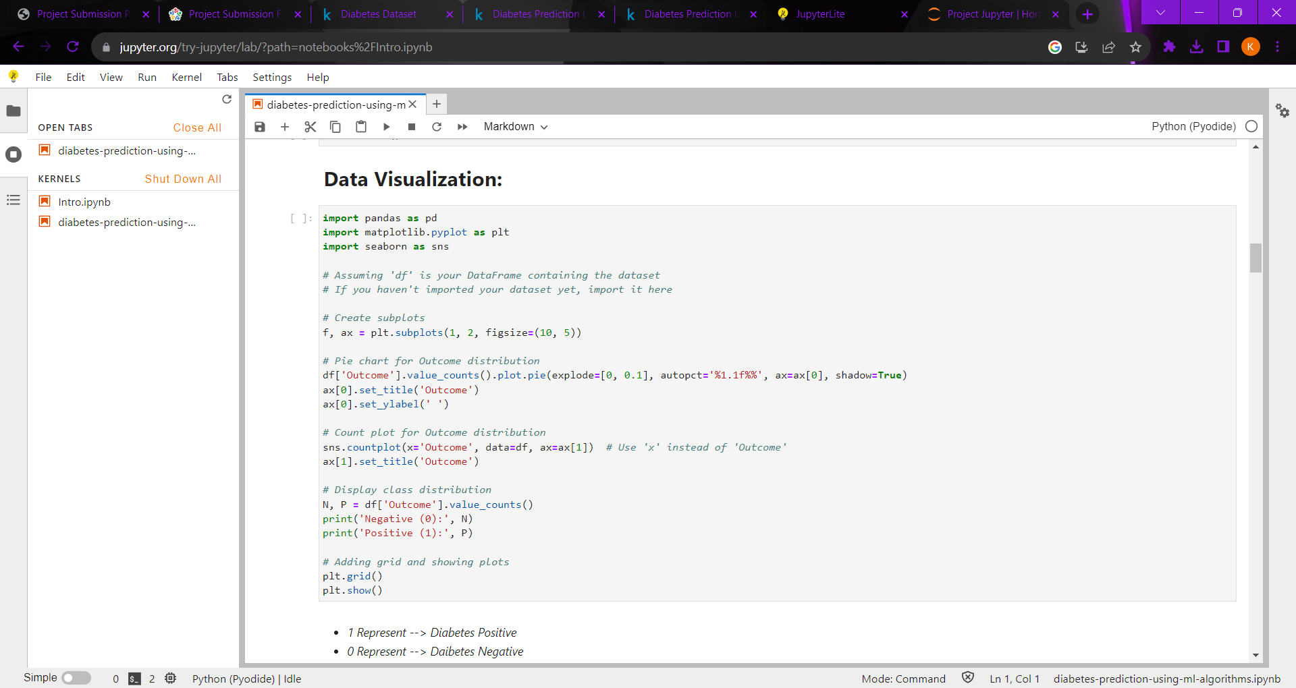

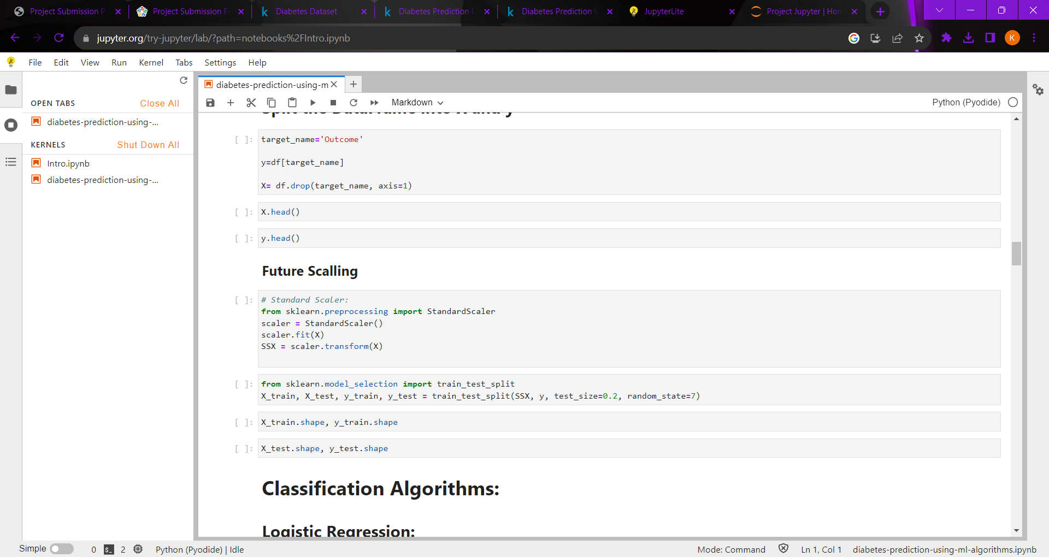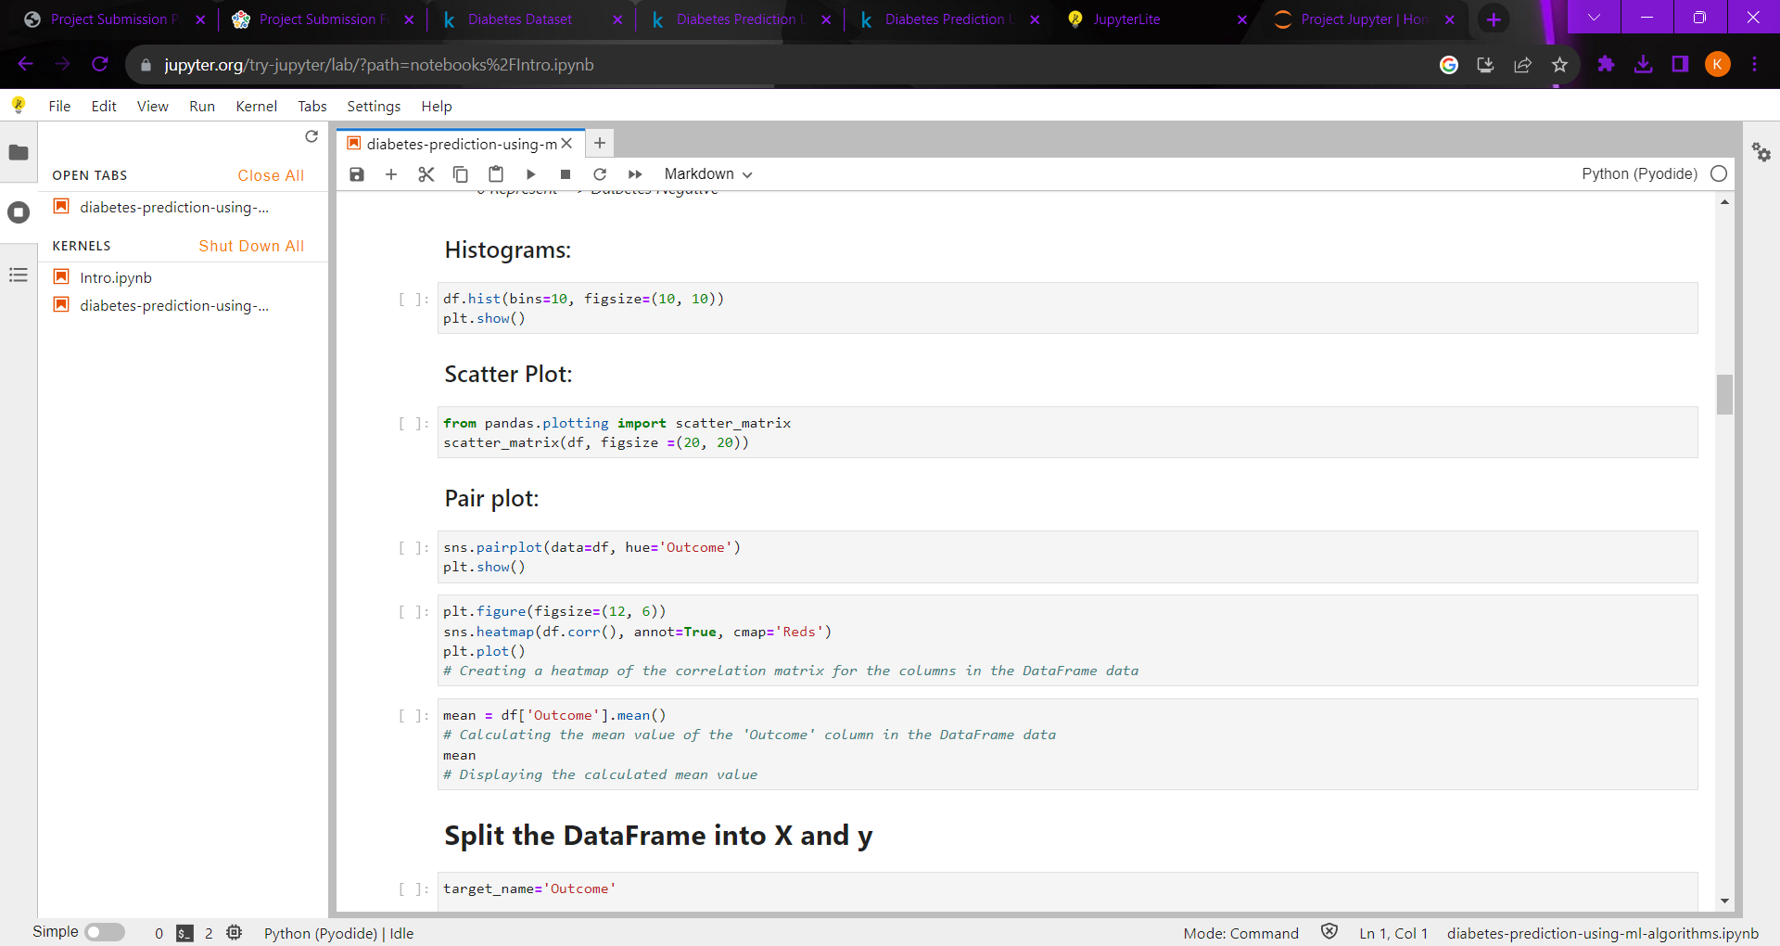

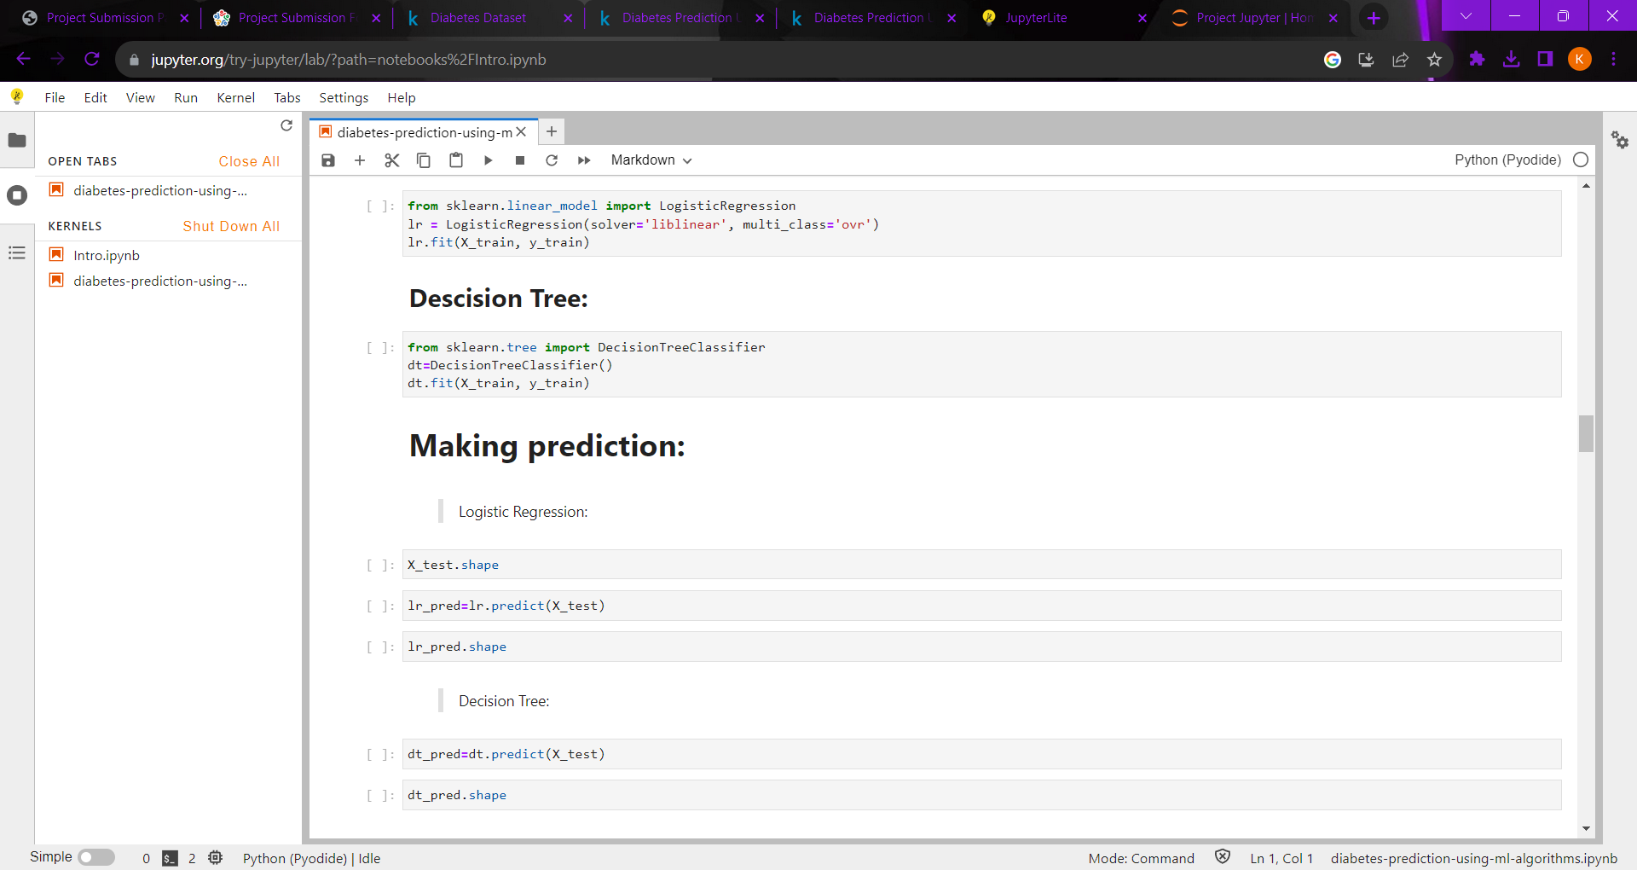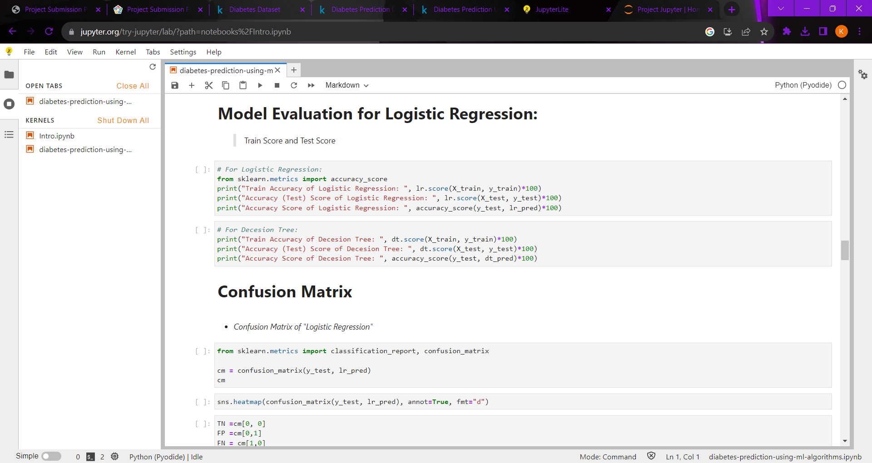

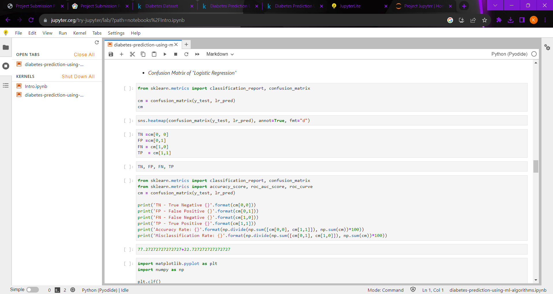

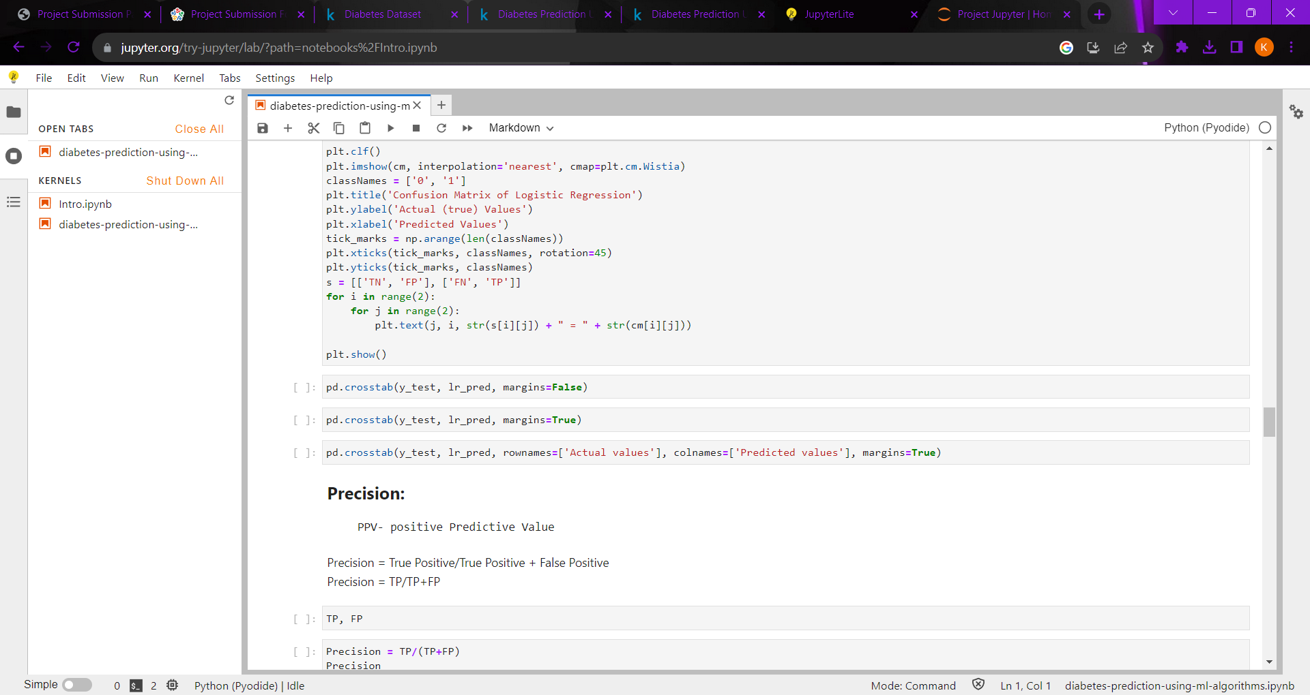

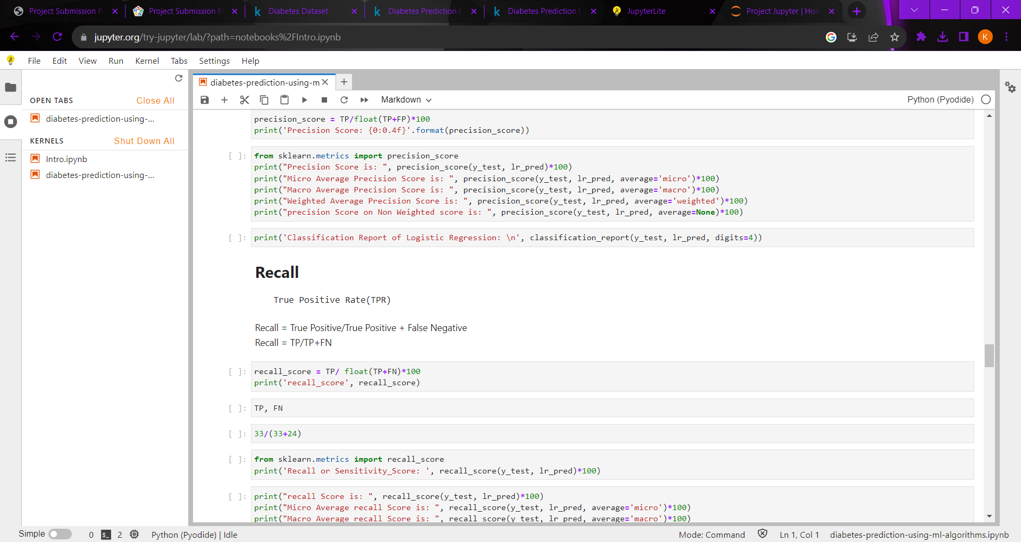

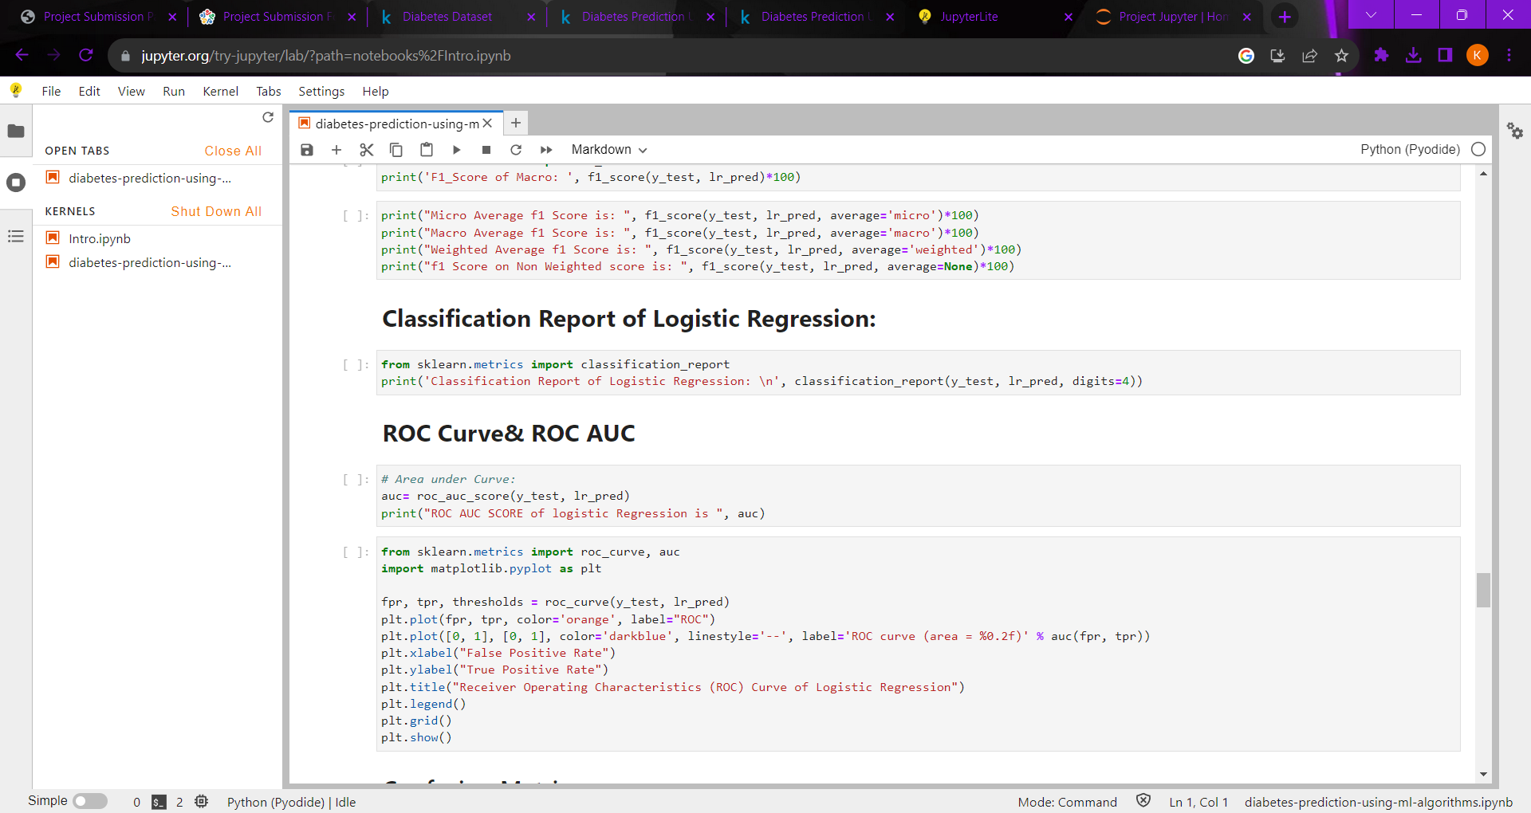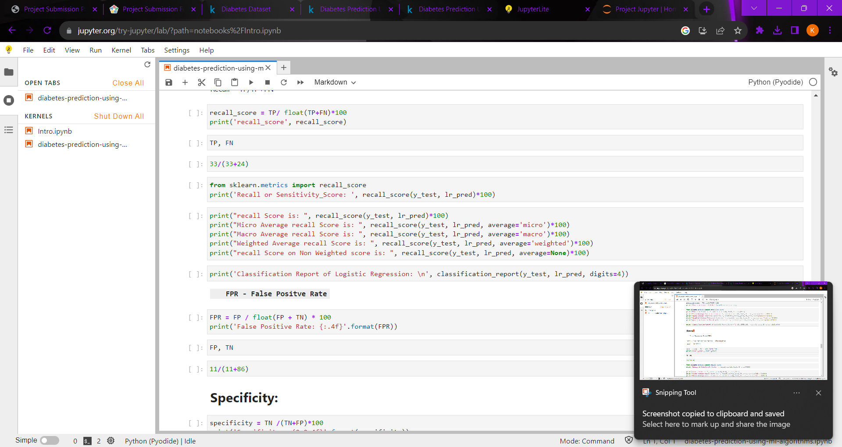



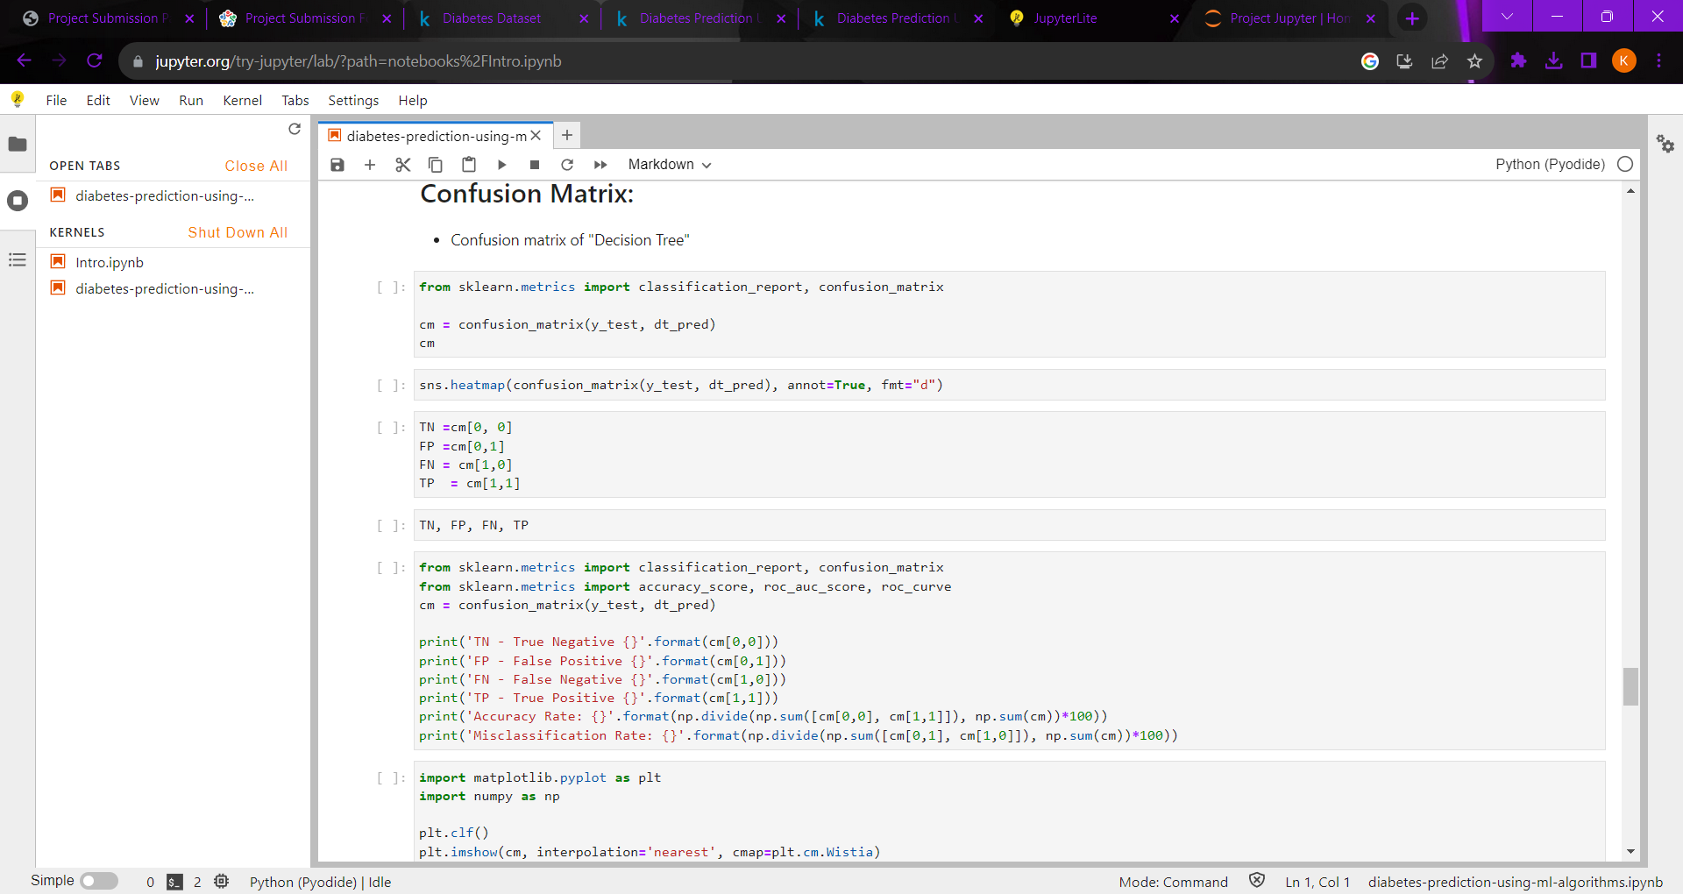

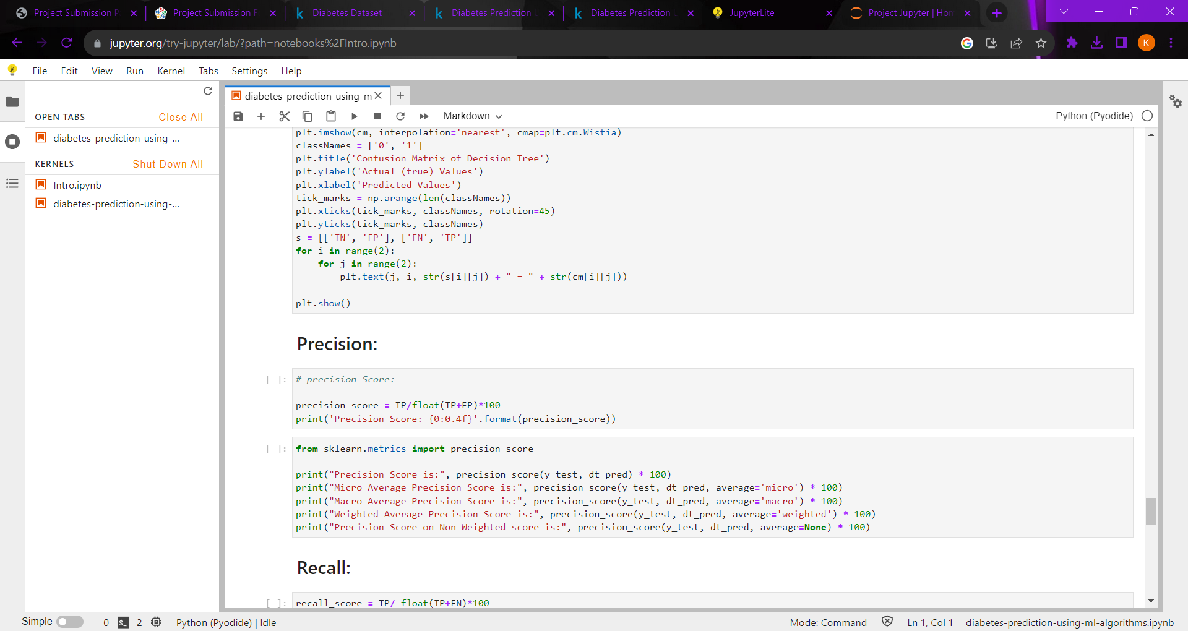

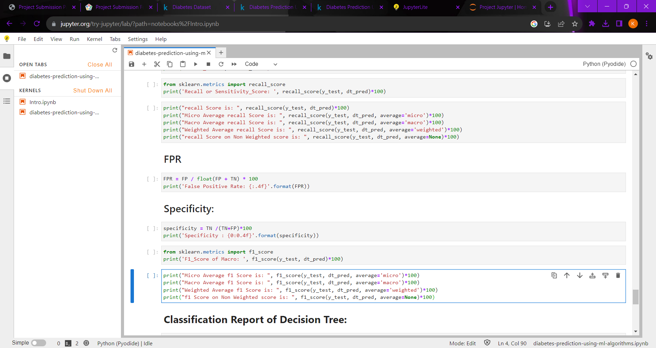

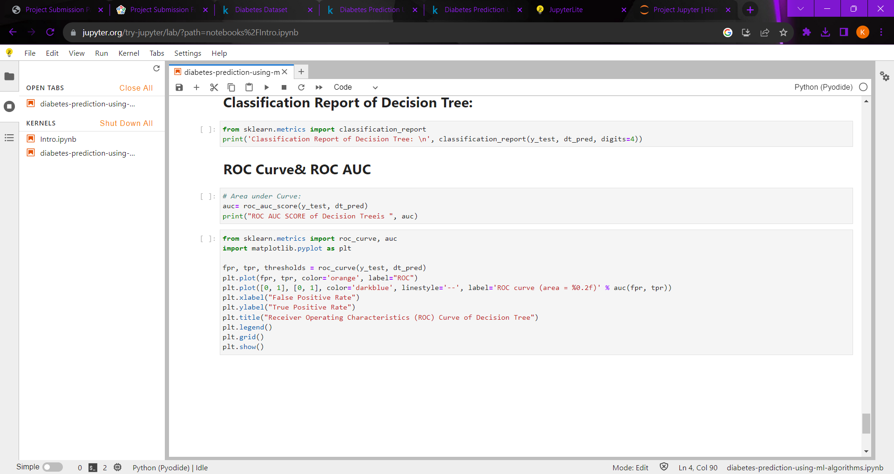

***ACCURACY WITH GRAP PLOTTED:***

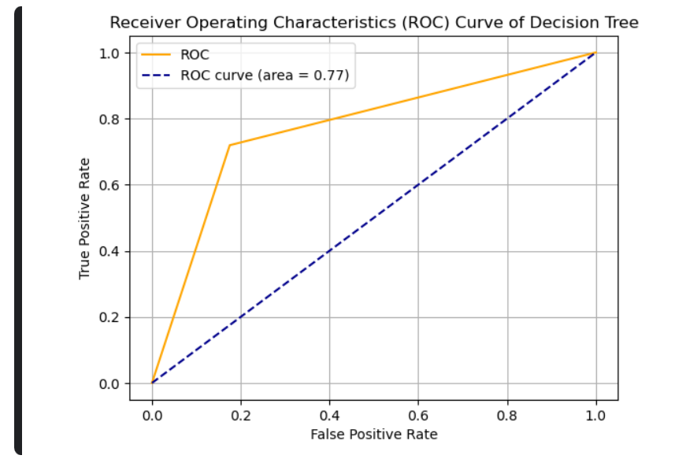

Precision Score: 70.6897

Micro Average Precision Score is: 78.57142857142857

Macro Average Precision Score is: 77.01149425287358

Weighted Average Precision Score is: 78.65353037766832

**ADVANTAGES & DIADVANTAGES:**

Advantages of AI-based diabetes prediction:

* Early detection: AI-based diabetes prediction can help to detect diabetes earlier, when it is more treatable and manageable.
* Personalized treatment: AI can help to develop personalized treatment plans for patients with diabetes, based on their individual risk factors and needs.
* Improved outcomes: AI can help to improve the overall health outcomes for patients with diabetes, by reducing the risk of complications and helping patients to live longer, healthier lives.
* Increased access to healthcare: AI-based diabetes prediction can be used to screen large populations for diabetes risk factors, even in remote or underserved areas. This can help to increase access to healthcare for people who may not otherwise have access to diabetes screening and prevention services.

Benefits of AI-based diabetes prediction:

* Reduced healthcare costs: By detecting diabetes earlier and preventing complications, AI-based diabetes prediction can help to reduce the overall cost of healthcare for patients with diabetes.
* Improved quality of life: By helping people to manage their diabetes more effectively, AI-based diabetes prediction can help to improve their quality of life.
* Increased productivity: By reducing the risk of complications from diabetes, AI-based diabetes prediction can help people to stay in the workforce and be more productive.

Disadvantages of AI-based diabetes prediction:

* Privacy and security concerns: AI-based diabetes prediction systems collect and process sensitive patient data. It is important to ensure that this data is protected from unauthorized access and use.
* Transparency and accountability: AI-based diabetes prediction systems should be transparent about how they work and how they make decisions. This is important for building trust with patients and caregivers.
* aware of this potential bias and to take steps to mitigate it.

Overall, the advantages of AI-based diabetes prediction outweigh the disadvantages. AI-based diabetes prediction has the potential to revolutionize the way we diagnose and manage diabetes. However, it is important to be aware of the potential disadvantages and to take steps to mitigate them.

**CONCLUSION:**

AI-based diabetes prediction has the potential to revolutionize the way we diagnose and manage diabetes. AI models can be trained to identify individuals at high risk of developing diabetes, diagnose diabetes early, and assess a patient's risk of complications. This information can be used to develop personalized treatment plans for patients and improve their overall health outcomes.

AI-based diabetes prediction is still in its early stages of development, but it has already made significant progress. AI models have been shown to be accurate in predicting diabetes risk and complications. AI-based diabetes prediction systems are also being deployed in clinical settings to help healthcare professionals diagnose and manage diabetes.

Challenges:

* Data privacy and security: AI-based diabetes prediction systems collect and process sensitive patient data. It is important to ensure that this data is protected from unauthorized access and use.
* Transparency and accountability: AI-based diabetes prediction systems should be transparent about how they work and how they make decisions. This is important for building trust with patients and caregivers.
* Equity and inclusion: AI-based diabetes prediction systems should be designed and evaluated in a way that ensures that they are fair and equitable for all patients, regardless of race, ethnicity, socioeconomic status, or other factors.
* Potential for bias: AI models can be biased, depending on the data that they are trained on. It is important to be aware of this potential bias and to take steps to mitigate it.

Opportunities:

* Improved accuracy and personalization: AI models can be trained on large datasets of patient data to improve their accuracy and personalization. This can lead to earlier detection and more effective treatment of diabetes.
* Integration with other technologies: AI-based diabetes prediction systems can be integrated with other technologies, such as wearable devices and electronic health records. This can allow for more continuous and personalized monitoring of a patient's risk of diabetes and diabetes complications.
* Expanded access to healthcare: AI-based diabetes prediction systems can be used to screen large populations for diabetes risk factors, even in remote or underserved areas

Overall, AI-based diabetes prediction has the potential to significantly improve the lives of people with diabetes. By addressing the challenges and seizing the opportunities, we can create a future where AI is used to help everyone live a longer, healthier life.